CHAPTER 1 Introduction of the Study

Background of the Study and Theoretical Framework

Food security is one of the major goals of all countries ensuring that their citizens have enough food supply for their consumption as part of the United Nations Sustainable Development Goals. The United Nations implements various programs and establishes organizations such as the World Food Programme and Food and Agriculture Organization to achieve the SDG 2: Zero Hunger by 2030. Unfortunately, the number of persons suffering from hunger, as assessed by the prevalence of malnutrition, began to slowly rise again in 2015 as reported by the United Nations (2021). Its current estimate is that nearly 690 million people are hungry, which is 8.9 percent of the world’s population. If current trends continue, the number of hungry people would reach 840 million by 2030.

Similarly, food security issues continue to plague farmers, food processors, merchants, and consumers in the Philippines. According to the National Social Weather Survey (2021) conducted between December 12 and 16, 2021, 11.8 percent of Filipino households, or around 3 million people, had experienced involuntary hunger - being hungry and not having enough to eat - at least once in the previous three months. The hunger rate in December 2021 is 1.8 percentage points higher than the 10% (estimated 2.5 million families) in September 2021. Various factors have contributed to this increase, Covid-19 pandemic is one of them that greatly affected the Philippine economy. Additionally, the low-priced rice from the National Food Authority has disappeared from the market. The cost of the cheapest commercial rice has increased, and consumers are now paying extra for the fundamental food.

Rice has been the primary staple food and is the most widely cultivated crop in the Philippines. It is not just an essential food to most Asian countries, but it also provides a source of income to its large chain of stakeholders on the demand and supply sides. As reported by the Department of Agriculture (2020), the Philippines recorded its highest rice production level at 19.44 million metric tons (MT) in 2020, much higher than in 2019. And it was discovered that the highest contributors to local rice production were mostly from the provinces. Among these provinces is Iloilo. Farmers produce metric tons of palay to sell in the private sector or in the government agencies that support local farmers. However, during the harvest season, most local farmers have limited options which push them to sell their produce even at a lower price due to the of lack capabilities for storage, transportation, and processing. This decreases the profit margin that causes some of them to have lower capital for the next planting season. Provided that they already have the “bagsakan” or buying station to sell their produce. In other cases, rice farmers rent the rice fields that they cultivate so most of them have no other choice but to take on loans from banks, agencies, or other entities such as multi-purpose cooperatives to cover their production costs.

To make things worse, the Rice Tariffication Law brought drastic changes that shifted the power of influence in the rice value chain. Rice Tariffication Law (RTL) or Republic Act (RA) 11203 (2018) is the policy of the State to ensure food security and to make the country’s agricultural sector viable, efficient, and globally competitive. The State adopts the use of tariffs instead of non-tariff import restrictions to protect local producers of agricultural products (Republic Act No. 11203, 2018). Referred to as the Rice Liberalization Law (RLL) by opposition groups, RA 11203 has replaced the quantitative restrictions on rice imports with a 35% tariff for ASEAN imports and a 50% tariff for non-ASEAN imports. With these rates, imported rice especially from Thailand and Vietnam sells at very low prices against which local farmers cannot compete. The RLL has also removed the regulatory functions of the National Food Authority (NFA) over rice importation and streamlined the process of acquiring import permits. Also, the NFA can only procure palay locally and maintain the optimal level of buffer stock at all times strategically located across the country. The NFA buys from farmers or farmers' organizations at the government-subsidized price to ensure that there is a market for farmer produce and that farmers receive a fair return on their investment in production. Under its Palay Procurement Program, the NFA Council decided to increase the NFA palay support price of P17/kilogram (set in 2008) to P19/kilogram for clean and dry palay applicably effective on September 13, 2019. Consequently, big businesses with massive capital have managed to dominate the industry and ship in massive amounts of cheap imported rice. Since January 2019, over 3 million metric tons (MT) of rice have been imported by the Philippines, thereby making it the world’s largest rice importer of the year (Purugganan, 2019).

This resulted in higher bargaining power for rice traders and lower bargaining power for the local rice farmers. Farmers had argued that the RTL would cause disastrous effects, but their worries and sentiments were brought into reality when it was passed into law. The market was flooded with cheap imported rice, lowered selling price of palay, and higher market prices for poor consumers. This also discouraged some local rice farmers to engage in agriculture because of poor incomes, precipitate land conversion and land grabbing, and reduced local rice production. With the liberalization of the rice industry, traders are hesitant to buy palay from the local farmers since imported rice is way cheaper and if they buy the palay, they still need to process it, incurring more expenses and effort to them.

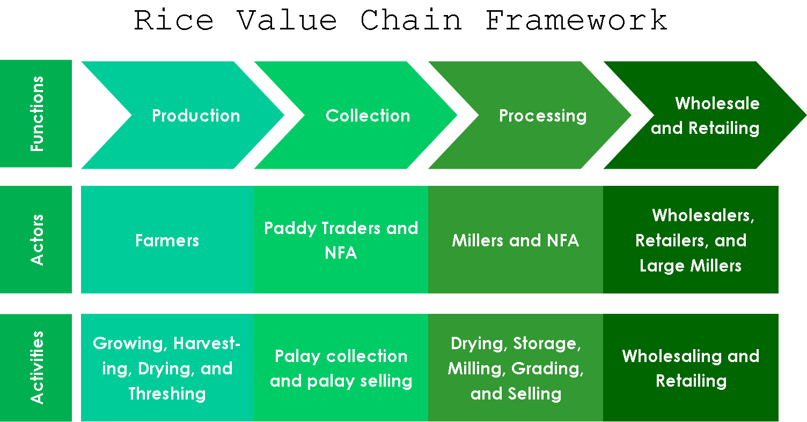

*Figure 1.* Rice Value Chain Framework

Furthermore, the market structure seems highly competitive and market players affirm the strong competitive pressures at every stage in the rice value chain. The Rice Value Chain (RVC) framework *(Figure 1)* used in the study spans the different interrelated segments or functions related to input production, collection, processing, and wholesale and retail of rice, which are carried out with greater interaction among the entire network of chain actors. It is influenced by four elements including end markets, support services, inter-firm relationships, and a business-enabling environment. The end markets into which the final product is sold provide market opportunities and sets the parameters for the chain’s growth. The chain is also supported by financial and non-financial support services that help enhance its performance. The flows of products, services, knowledge, and information in the chain are affected by the quality and nature of inter-firm relationships and coordination among chain actors. Moreover, the performance of the chain and its chain actors are also governed by business-enabling environments such as policies, laws, and regulations. In some stages of the chain, price manipulation is also inevitable to happen especially in periods of scarcity. The problem is that the farmers are the ones who take the brunt of these issues since traders are the ones who set the buying prices of palay.

Currently, the NFA is having problems in managing their data, collecting other necessary data during their procurement and distribution processes, consolidating their data from the lowest to higher levels of the organization and monitoring the prices of rice in the market. The NFA’s operations, data collection, and management can be improved by streamlining their existing processes and incorporating them into a system. The researchers proposed this study entitled “Rice Procurement and Distribution Management System” to address some problems faced by the local farmer and some parts of the rice value chain. These include the low bargaining power of farmers, lack of alternative channels in selling palay, limited palay price monitoring at a micro level, and data management during procurement and distribution of NFA.

Objectives of the Study

This study generally aims to develop a Rice Procurement and Distribution Management System.

Specifically, this study aims to:

1. Develop a marketplace platform that connects farmers, traders, and the NFA for selling and buying rice produce;
2. Develop a distribution scheduling model for NFA to allocate and distribute the rice produce;
3. Develop an inventory management model to track the stock levels in the warehouse; and
4. Evaluate the system based on ISO/IEC 25010.

Significance of the Study

The study aims to help Filipino farmers in selling their palay produce in the market at a reasonable price and improve the current processes of the NFA in procurement, distribution, and inventory management. This study will also give information on the prices of rice in the market for monitoring.

The people or institutions that can benefit from this study are:

Rice Farmers. This study offers efficient, sufficient, and reliable information that could greatly help the rice farmers in choosing the possible buyers of their products which can increase their bargaining power.

Traders. This study offers efficient, sufficient, and reliable information that could greatly help the traders to find and buy palay.

National Food Authority. This study is centered on giving more efficient, sufficient, and reliable information on rice procurement and distribution of rice. The system can also greatly help the NFA to improve information dissemination within the organization.

Researchers. The information and insights in this study can provide researchers in studying the rice value chain in the Philippines.

Definition of Terms

For better understanding, the following terms were defined conceptually and operationally:

*Distribution –-* to spread the product throughout the marketplace such that many people can buy it or consume it.

In this study, “Distribution”, is the process of selling, transferring, and delivering milled rice for relief operations, police/ military food allowance, and areas that lack a supply of rice.

*Farmer* —- a farmer is someone who works under the umbrella of agriculture, producing a variety of food products for human and animal consumption. There are several kinds of farmers ranging from farmers who raise animals to farmers who grow crops.

In this study, “Farmers” refers to a user of the system who sells palay.

*Financial Exchange* —- an exchange is a marketplace where securities, commodities, derivatives and other financial instruments are traded. The core function of an exchange is to ensure fair and orderly trading and the efficient dissemination of price information for any securities trading on that exchange.

In this study, “financial exchange” refers to the marketplace where palay is traded, ensuring that the trade between farmers and palay traders is fair and systematic and there is transparency of palay price information to all users.

*Firebase —-* a Google-backed application development software that enables developers to develop iOS, Android, and [Web apps](https://www.techtarget.com/searchsoftwarequality/definition/Web-application-Web-app).

In this study, “Firebase” refers to the back end of the system. A database of a system.

*Inventory Management —-* refers to the process of ordering, storing, using, and selling a company's inventory. This includes the management of raw materials, components, and finished products, as well as warehousing and processing of such items.

In this study, “Inventory Management” refers to the process of procurement, storing, processing of palay, and the distribution to their respective recipients of the NFA.

*Marketplace***—-** a platform where vendors can come together to sell their products or services to a curated customer base.

In this Study, “Marketplace” is a platform where farmers sell their palay, and the trader and NFA buy palay produce.

*NFA (National Food Authority)* —- an agency of the Philippine government under the Department of Agriculture is responsible for the food security of the Philippines and the stability of supply and price of the rice as the main grain of the Philippines.

In the study, the “National Food Authority'' refers to a main user of the system or the admin of the system.

*Palay* —- rice at any stage before husking.

In this study, “palay” refers to a stage of rice before being milled in the system.

*Procurement —-* act of obtaining goods or services, typically for business purposes. Procurement is most commonly associated with businesses because companies need to solicit services or purchase goods, usually on a relatively large scale.

In this study, “Procurement”, is the process of buying the palay from the local rice farmers. The NFA is actively doing procurement operations for the local rice farmers if there is a lack of traders who will buy their palay produce.

*ReactJS —-* is a JavaScript library used in web development to build interactive elements on websites.

In this study, “ReactJS” refers to the JavaScript library that the researchers used in developing the system.

*Rice —-* Rice, (Oryza sativa), edible starchy cereal grain, and the grass plant (family Poaceae) by which it is produced.

In this study, “Rice” refers to the primary product in the system.

*Scheduling Model —-* allows one to see the big picture and focus on the primary task to be completed.

In the study, “scheduling model” refers to the planning of the distribution of rice. When and to whom the rice should be distributed in order to disperse the old stock rice from the inventory.

*Trader —-* a person who buys and sells goods.

In the study, “trader” refers to a person who buys palay or rice to the farmer using the marketplace.

*Value Chain —-* the different interrelated segments or functions related to input provision, production, aggregation, processing, and marketing, which are carried out with greater interaction among the entire network of chain actors.

In the study, “value chain” refers to the series of consecutive steps or processes that the rice undergoes from production of palay to buying of the consumers. The value chain is composed of interconnected functions which are production, collection, processing, and marketing that are performed by their respective actors.

Delimitation of the Study

The study focuses on rice procurement, distribution, and rice market activities for the farmer, traders, and NFA. The system has a marketplace where the traders, farmers and NFA interact through buying and selling. However, the proposed system does not include other crops and it is only limited to palay and the financial exchange between the farmer to trader and farmer to NFA is not facilitated by the system. The proposed system captures the process of buying and selling palay from farmers to traders or NFA. In NFA, the proposed system collects the procured palay to procurement and distribution, then added to the inventory adopting the 3-,6-,9-month model of NFA and generates visualization to the dashboard.

Chapter 2 Review Of Related Literature

Review of Existing and Related Studies

*Current System*

The rice supply chain in the Philippines is composed of interconnected processes in the chain that are performed by actors namely, the farmers, rice traders, rice millers, NFA, wholesalers/retailers, and consumers. The farmers sell their palay produce to the market through traders or collectors. This interaction should have been mutually beneficial, but the traders have more bargaining power over the farmers because aside from having the transportation and storage capability that farmers lack, they also set the selling price of the palay. This problem will also escalate if the trader has no competition which leads to hoarding. This can be prevented before by the NFA because they can inspect the warehouses of the traders. Now, NFA can only serve as an alternative option for the farmers to sell their palay.

The farmers sell their palay to the NFA through their warehouses. These warehouses have personnel who facilitate the procurement, inventory management, quality control, and distribution processes. The NFA records their procurement and distribution in an excel file that would be sent to the branch office. The recorded data are aggregated so the NFA cannot track where the palay were procured and where they are distributed. This also led them not to be able to gain substantial insights from the data they collected. The NFA then creates reports out of the aggregated data they collected which are then sent to higher offices.

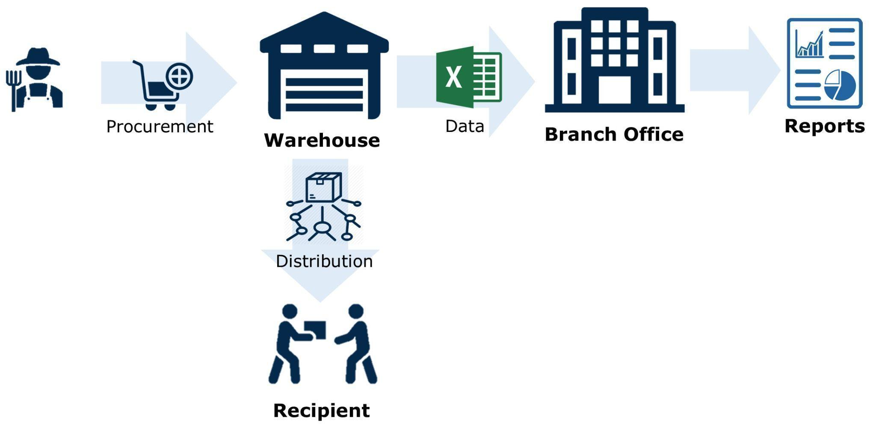

*Figure 2.* The Current System of the National Food Authority

*Related Systems*

The main food source in the Philippines is rice, which provides over 60% of the daily required consumption of calories per person. The production of palay accounts for 35% of the total harvested area, making it the most frequently produced crop in the nation. Free and fair competition across the whole value chain is essential to the effective operation of the rice market. Free and fair competition across the whole value chain is essential to the effective operation of the rice market. But recently, issues regarding the level of competition in the rice markets have been brought up. The industry, encompassing production, harvesting, milling, distribution, and trading, is quickly evaluated in this study. (Briones, 2019)

Due to the region's resilient rice farmers, palay production in Western Visayas climbed by 12.15 percent in the first half of 2020, according to the Department of Agriculture (DA) in region 6. (Western Visayas). In spite of the dangers posed by the coronavirus disease (Covid-19) pandemic, the farmers showed their commitment and passion to provide the general public access to enough, reasonably priced, and secure food, according to DA-6 Regional Director Remelyn Recoter. (Nicavera, 2020)

In the journal by Abrogena et al. (1970), palay/rice trading in the Philippines: an evaluation for the rice Research & Development agenda explains that trading in palay and rice involves sourcing, shipping, storing, milling, and distribution. Poor grain quality caused by mixed types, spotted and discolored palay, and high impurities was the main issue with palay procurement. Poor farm-to-market load truck prohibition and excessive transportation prices were the main transportation issues. Due to insufficient drying facilities, nonselective and unlimited rice disposal by the National Food Administration (NFA), and the possibility of excessive losses, damages, and the unpredictability of future palay prices, traders found palay storage to be an expensive and risky venture. The millers' main issue was low milling recovery. It happens as a result of a high proportion of broken and empty grains, high palay contaminants, and ineffective aged rice mills. The fast growth in the number of traders led to more intense competition among them, which is now being exacerbated by NFA action. The importation of rice and NFA's involvement in palay/rice trading significantly reduced traders' motivation to invest in extensive palay/rice storage. Due to the diminished competitiveness of local palay as a result of importation, palay traders allegedly passed on the alleged drop in their expected profit to farmers in the form of a lower purchase price. The importation steadied the price and supply of rice, but it negatively impacted the growth of the grain trading industry's private sector. On the other hand, Harahap et al. (2019) says that one of Indonesia's commodities that has great potential is rice. Indonesia's main food is rice, a vital commodity. Every year, the pace at which the population grows also sees a growth in rice consumption, but this rate is not equal to the rate at which production and harvesting areas grow. The sequence of rice processes undergoes several stages of the supply chain: agriculture (growing), harvesting, harvesting, packing, and transportation. In terms of actors, the supply chain consists of several businesses such as farmers, local wholesalers such as collecting traders, traditional retailers/supermarkets, and customers.

The domestic rice buying program supports farmers' incomes while also increasing rice inventories for the public food grain distribution system. The assistance price offered by the Bangladeshi government exceeds the cost of manufacturing. To comprehend the level of food security at the household level, we assess the efficacy of rice procurement programs and analyze the variables impacting farm level rice stocks. Additionally, stocks of coarse rice at the farm level vary positively in relation to own price but adversely in relation to consumer price. (Mohammad, 2015)

*Supply Chain Management of Rice in India: A Rice Processing Company’s Perspective*. This study by Sharma et al. (2013) focuses on management of rice in India. Given that some paddy varieties are seasonally, and geographically specialized, seasonal forecasting and procurement are also crucial. The paddy processing company should predict their need for these types for the entire year and purchase them throughout their season in the specific area. The cost to the rice processing company of acquiring certain varieties of paddy during the off-season may increase. A supply chain's efficiency can be increased by an effective logistics system, whereas one that is ineffective will only worsen the situation. India's rice supply chain is struggling to meet demand due to high logistics costs and timely inventory availability. It's difficult to balance the price of logistics with on-time delivery. Either the inventory is delivered later than expected, or the shipping costs are higher than anticipated by the rice processing unit. The company that processes rice is needed to reduce transportation delays while minimizing its export and inbound logistical costs.

Similar to this study, our system also aims to forecast the supply of palay and demand of rice through the procurement and distribution operations of the National Food Authority (NFA). This secures the supply for the buffer stock and guarantees that the NFA would buy the palay from the local farmers considering that NFA is the farmer’s last resort to sell to.

Goel and Bhaskaran (2006) on their paper *Marketing Practices and Distribution System of Rice in Punjab, India* which focuses on the marketing practices, market structures, and firms' motives for vertical coordination of the paddy-rice distribution system during the post green revolution period in the Punjab state of India. The study's primary data comes from secondary sources that have been published, and it also draws heavily from in-depth interviews with market agents along the full supply chain, from producers to merchants. The study emphasized the public sector's emergence as a major player in the paddy (non-basmati) wholesale markets, dishonest practices for paddy/rice supplies, significant price differences between issues for families living below and above the poverty line, decreased offtake from the public distribution system, and the introduction of numerous schemes to clear out excess stocks and boost market efficiency. Supply agents also provide a crucial strategic link for rice sales. Private milling, however, picks up steam because of higher profitability, especially during the industry's downturn.

Nurprihatin et al (2021) on their study *Optimizing rice distribution routes in Indonesia using a two-step linear programming considering logistics costs* states that tThe rise in rice consumption needs to be countered by a rise in rice output. However, even though there was a claimed surplus of domestic rice output, there were also more imports of domestic rice. The 2.2 million tons of imports in 2018 demonstrated that surplus rice production is not successfully used as a benefit in bridging the deficit in several Indonesian areas. The government can better meet the demand for the shortage due to the contribution of this study in designing distribution routes. The two-step linear programming approach is used in this work. The Capacitated Vehicle Routing Problem (CVRP) model comes after the transportation model in the orderly process. By transferring commodities from provinces with an excess of supply to those with an excess of demand, this two-step linear programming achieves the best overall result. The findings indicate that using this technique to meet demand will result in cost savings over importing rice.

This study is a great example that shows some factors that affect the selling of palay. Most Filipino farmers lack resources for storage and transportation for their palay produce. This, aside from the inherent power of traders of setting the buying price of palay are the reasons why rice farmers have low bargaining power. Traders or procurement centers who have warehouses for storage and vehicles for transportation have the advantage of procuring directly from the local rice farmers since it decreases the time, cost and effort of the farmers in selling their palay produce.

In the study of Alfazah et al. (2019) entitled *Designing Procurement Process Monitoring Dashboard for Supporting Food Security Supply Chain Risk Management System in Indonesian Bureau of Logistics* emphasizes that due to its potential to impact Indonesia's economic stability, rice is one of the most significant and crucial commodities. The Indonesian Government's Indonesian Bureau of Logistics (BULOG) organization is in charge of overseeing the distribution of the rice commodity. The purchase process for rice is the most important process. Therefore, the procurement process must include risk management and mitigation measures. The Supply Chain Operation Reference (SCOR) Method, Failure Mode and Effect Analysis (FMEA) Method, and Analytical Hierarchy Process are used in this paper to develop a strategy for risk mitigation and a monitoring dashboard to maintain and monitor the risks of the procurement process of rice commodities (AHP). There are 12 risk events and 16 risk causes, which are separated into three pillars of food security and for mitigation measures, into three primary reasons and three alternatives to any major cause, according to the results of risk identification obtained through fieldwork and expert interviews.

The Rice Procurement and Distribution Management System is a study that anchors food security and sustainable agriculture, similar to this study but has a different approach. The study’s goals lean towards effective and efficient information management and sharing between the farmers, LGU, and the NFA. The increase of collaboration between these players helps them meet their needs to operate and function in the rice value chain.

The study *Feasibility of rice procurement programme for poor farmers in Bangladesh by Alam et al. (2017) has* been conducted to examine feasibility of rice procurement system and factors influencing farmers to sell rice at procurement centers in an area of Jamalpur district. In total, 45 sampled farmers from Jamalpur district, comprising both participants and non-participants, and 15 millers, were spoken with. The respondents were chosen using a stratified sample procedure.

In connection to this study, the system aims to help farmers to see the different palay prices and in choosing procurement centers or traders that can decrease the time, cost and effort of the farmers in selling their palay produce.

Using the value chain analysis (VCA) framework, Mataia et al. (2020) *Rice Value Chain Analysis in the Philippines: Value Addition, Constraints, and Upgrading Strategies* analyzed the rice value chain (RVC) in the Philippines, examined the value additions, identified constraints, and proposed upgrading strategies to enhance the competitiveness of the rice industry and the specific segments in the RVC. The RVC of the nation begins with the delivery of inputs for the production of paddy and concludes with the consumption of milled rice. The traditional multi-layered supply chain that dominates the RVC is made up of interconnected chain actors that include rival farmers, paddy traders, millers, and rice traders in each segment. Frequently, brokers are also used in both the paddy aggregation and rice distribution processes, which raises the cost of marketing. The primary barrier found in the RVC included high labor and material costs, low yield-related paddy and rice production and marketing costs, and a lack of essential market facilities (such as modern mills, dryers, affordable transport, and energy). These factors led to high domestic paddy and rice prices and low competitiveness of the entire rice VC. The rice industry should focus on developing and promoting technologies that increase yield, decrease postharvest losses, and minimize costs, as well as those that increase overall efficiency in the RVC, such as investments in enabling infrastructure and facilities for transport, handling, storage, drying, and milling, in order to increase its level of competitiveness.

Similar to this study, the Rice Procurement and Distribution system aims also to upgrade strategies to enhance the competitiveness of the rice industry by providing sufficient and reliable information about palay prices, supply, and demand of palay that helps minimize hoarding activity in the rice industry. The system also provides management support in the procurement, inventory, and distribution operations of the NFA.

Chapter 3 Research Design and Methodology

Description of the Proposed Study

Information Systems (IS) have been used in different stages in the rice value chain to increase efficiency, productivity, and effectiveness and minimize costs. Starting from the production stage until the marketing of the rice. Our study, the Rice Procurement and Distribution Management System aims to improve and provide information about palay prices, procurement, and a distribution scheduling model to allocate and distribute the rice produce and an inventory management model to track stock levels in the warehouse.

With the rapid advancement of technology, the researchers developed a system that can be used as a primary source of information exchange tool by integrating rice procurement and prices information from the government agencies to the farmers. A system that can be able to aggregate and visualize data for local farmers, traders, and NFA to generate information. Furthermore, the system can lessen the workloads of the employees specifically in NFA to gather data and generate information.

#### *Assumptions and Preconditions*

The proposed Rice Procurement and Distribution Management System will be used by local farmers, traders, and the NFA. The system has three primary users: (1) NFA, (2) Traders, and (3) local farmers.

First, NFA or National Food Authority, the proposed system enables the NFA user to input and record data in rice procurement and distribution to easily generate information to visualize and project the data. Furthermore, it enables users to manage their inventory and schedule the allocation of rice to be distributed. The manual activities must be done before making changes in the system. For example, the palay must be milled physically before changing its status in the system. Moreover, Only the authorized NFA staff can use and handle the system.

Secondly, Traders, the proposed system enables the traders to see the available selling palay and start bidding. The traders are assumed to be registered by the BIR to legally operate their business.

Lastly, Local Farmers, whenever the local farmer logs in the system. The proposed system authorized the farmer to choose buyers who bid in the palay and see the visualized price of the palay. They should be registered by the Department of Agriculture as local farmers.

Methods and Proposed Enhancements

This study is determined to develop a system that helps Filipino farmers in selling their palay produce in the market at a reasonable price, encouraging rice traders to buy palay from the local farmers, and improve the current processes of the NFA in their procurement, distribution, and inventory management.

The system is developed as a web application that needs a working computer and internet connection to run the system. This is in consideration that technology is being more accessible even to some remote areas of Iloilo province.

One of the main features of the system is the marketplace where rice farmers can sell their produce that is within the market price range of palay. The rice traders can then buy the palay in the marketplace by bidding. This encourages competition among traders which increases the bargaining power of farmers in the market and decreases the chances of monopoly of palay. For the posted palay with no potential buyer, the NFA can then bid for it for their procurement.

The inventory management involves the monitoring of stocks of palay and milled rice of the NFA. It incorporates the 3-6-9-month rule where the procured palay should not be more than 3 months old after harvesting, it should be milled after 6 months, and should be distributed after 9 months. The procurement is done in batches depending on the set target amount of rice (in metric tons) to avoid over stock or under stock of rice in the inventory, maintaining the stock at the optimal level. The distribution scheduling helps in distributing the milled rice whether for relief operation during calamities, food allowance of the Philippine National Police, or the market to prevent the stocked rice in the warehouses to rot. A demand calculator is also included to calculate the estimated amount of rice to be distributed based on the per capita consumption of Filipinos.

Demand calculation: demand = population * per capita consumption per day * days

Components and Design

*System Architecture*

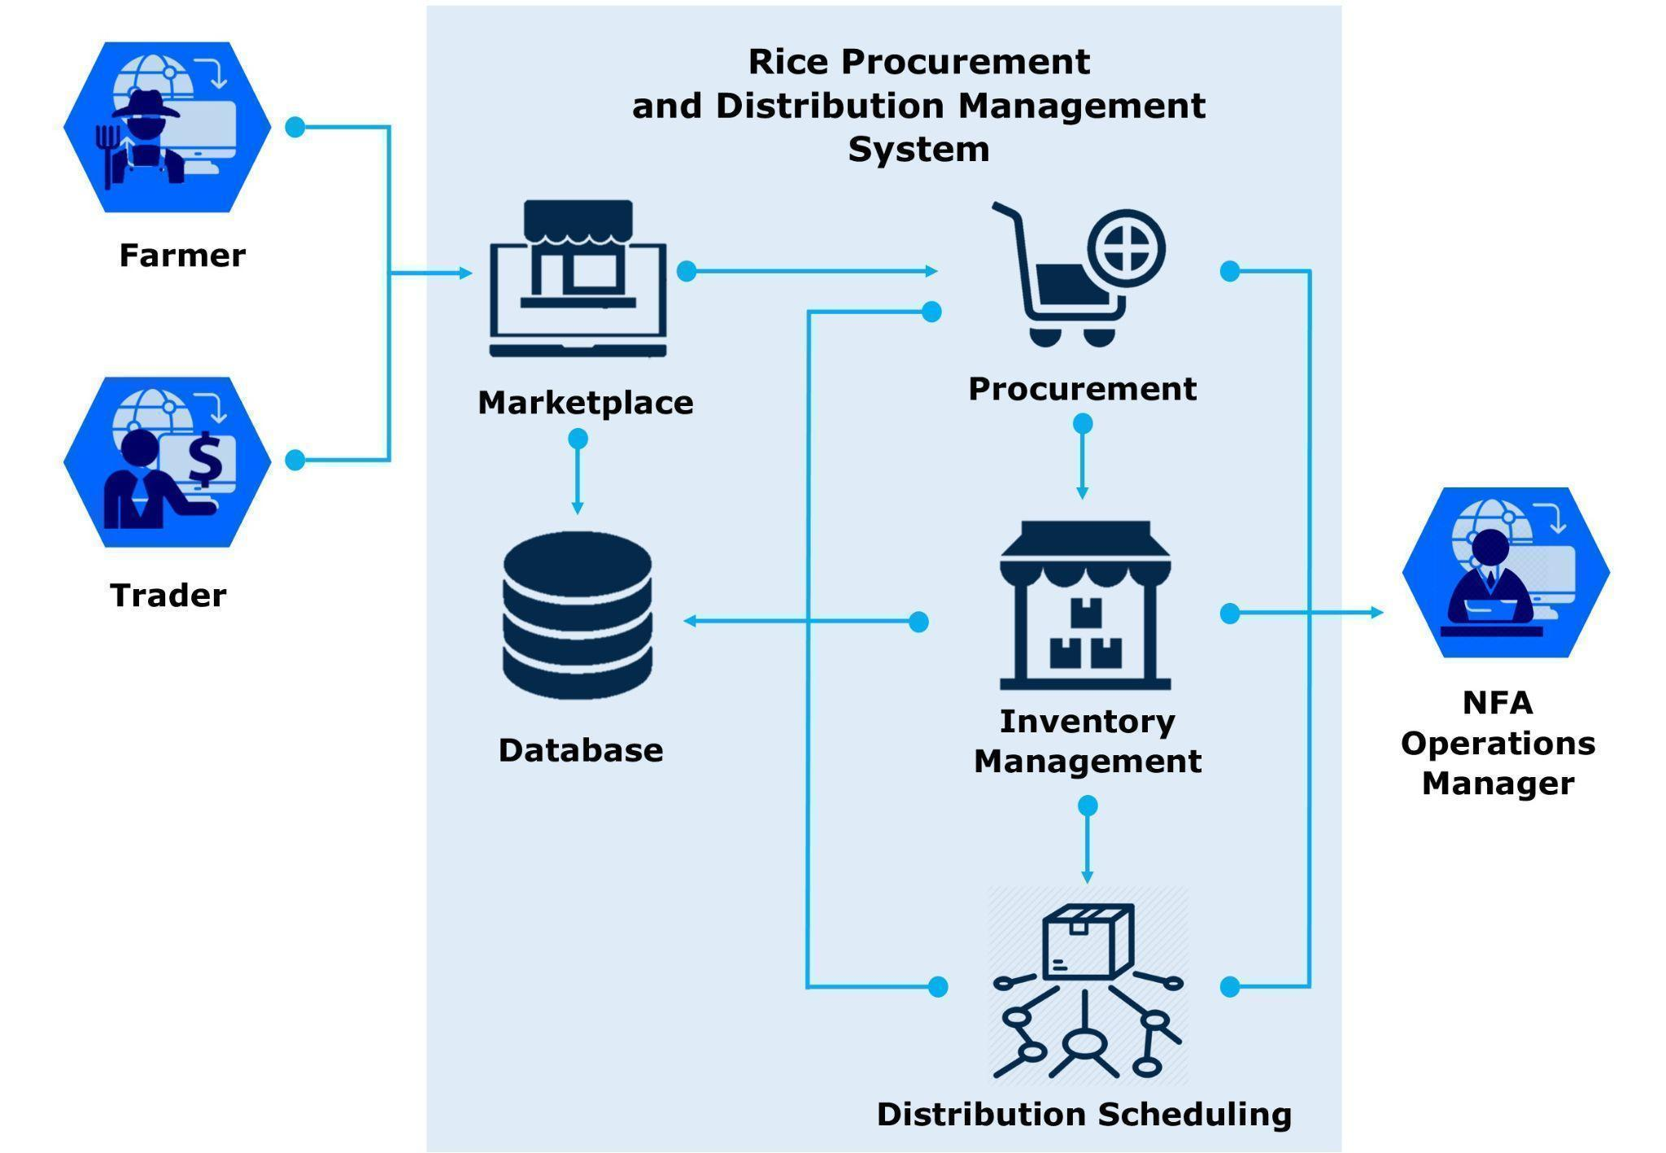

*Figure 3.* Rice Procurement and Distribution Management System Architectural Design

The farmer, traders, and NFA Operations Manager as the user can access the system through the Internet using their computers. They first need to register for them to use the system. Once registered, the users can log in using their account username and password and are redirected to the marketplace. The marketplace is where the farmer can post the palay they want to sell and both traders and NFA can buy palay by bidding. The transaction and procurement are saved in the database. The NFA can procure palay from the palay sold by the farmers in the marketplace. It is then updated to their inventory to be managed using the 3-6-9 rule used by NFA. The palay to be procured should be less than 3 months old, milled after 6 months old, and distributed before 9 months old. The distribution schedule allocates the milled rice needed for distribution. The three distribution channels of NFA are relief operations, food allowance for Philippine National Police, and the market. The demand calculator calculates the demand needed for distribution during relief operations with a specific population and the number of days of consumption. The operation of distributing rice prevents overstocks and over-aging of rice in their warehouses.

*Database Design*

The database design illustrates the structure of the database and the normalization of tables.

User

|  |  |  |  |  |
| --- | --- | --- | --- | --- |
| user_id | last_name | first_name | gender | date_of_birth |
| 092735 | masipag | adolfo | m | 04/27/1999 |
| 082736 | demo | trader | m | 09/23/1971 |

|  |  |  |  |  |
| --- | --- | --- | --- | --- |
| barangay | municipality | contact_num | user_type | email |
| Duyanduyan | Santa barbara | 09237465298 | Farmer | adolfomasipag@gmail.com |
| Sta. Rita | Anilao | 09302375251 | Trader | trader@example.com |

|  |
| --- |
| household_monthly_income |
| 10,000 |
| 15,000 |

*Figure 4.* The Database Design of the Proposed System

NFA Operations Personnel (Admin)

|  |  |  |
| --- | --- | --- |
| *user_id* | email | password |
| 107646 | nfa@example.com | 123456 |

Selling

|  |  |  |  |
| --- | --- | --- | --- |
| selling_id | harvest_date | num_of_sacks | kilo_per_sack |
| 985679 | 02/3/2022 | 50 | 40 |

|  |  |  |
| --- | --- | --- |
| price_per_kilo | seller_id | *palay_id* |
| 20 | 092735 | 985679 |

Palay

|  |  |
| --- | --- |
| palay_id | palay_variety |
| 985679 | sinandomeng |

Transaction

|  |  |  |  |
| --- | --- | --- | --- |
| trans_id | trans_date | num_of_sacks | price_per_kilo |
| 765898 | 03/26/2022 | 40 | 20 |

|  |  |
| --- | --- |
| buyer_id | *selling_id* |
| 123465 | 765898 |

(Cont.)

Procurement

|  |  |  |  |
| --- | --- | --- | --- |
| proc_id | proc_date | num_of_sacks | price_per_kilo |
| 543799 | 03/26/2022 | 40 | 19 |

|  |
| --- |
| *selling_id* |
| 765898 |

Distribution

|  |  |  |  |
| --- | --- | --- | --- |
| dist_ID | dist_date | num_of_sacks | recipient_type |
| 679097 | 04/26/2022 | 100 | Relief operation |

|  |  |
| --- | --- |
| event_purpose | *recipient_id* |
| Relief operation for the victims of typhoon Karding. | 80750 |

Recipient

|  |  |  |  |
| --- | --- | --- | --- |
| recipient_id | rerecipient_namee | recipient_type | barangay |
| 80750 | Magdalena | relief Operation | zone VI |

|  |  |
| --- | --- |
| municipality | province |
| Sta. Barbara | Iloilo |

(Cont.)

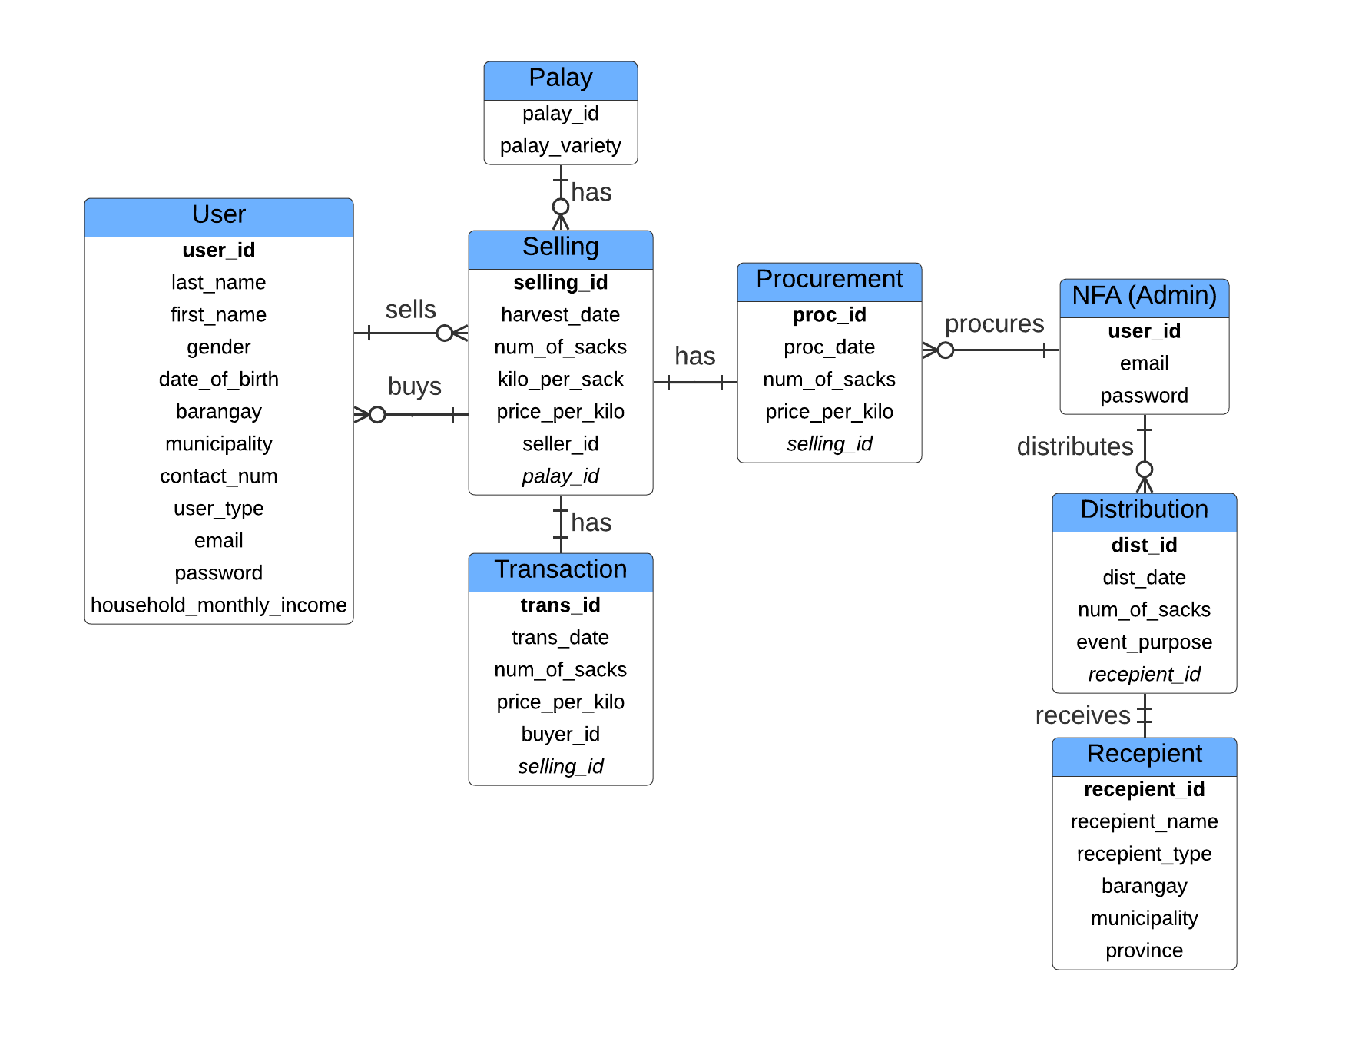

*Figure 5.* Entity Relationship Diagram

(Cont.)

*Procedural Design*

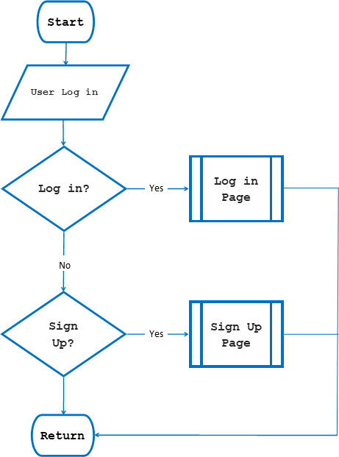

*Figure 6. User* Log in and Sign-Up

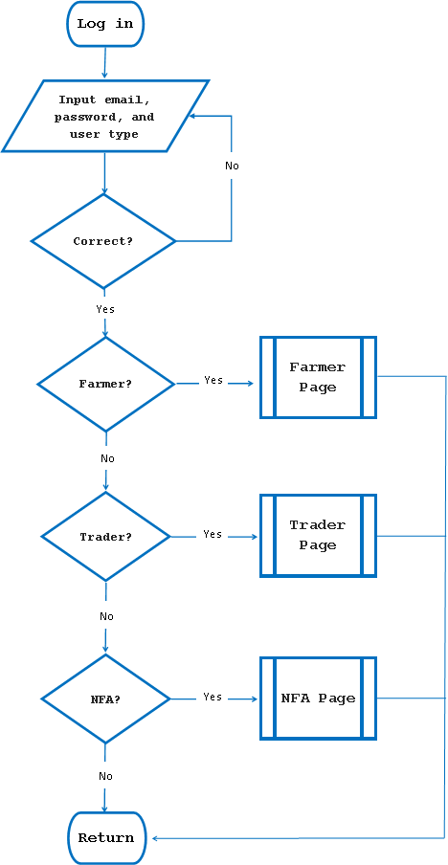

(Cont.)

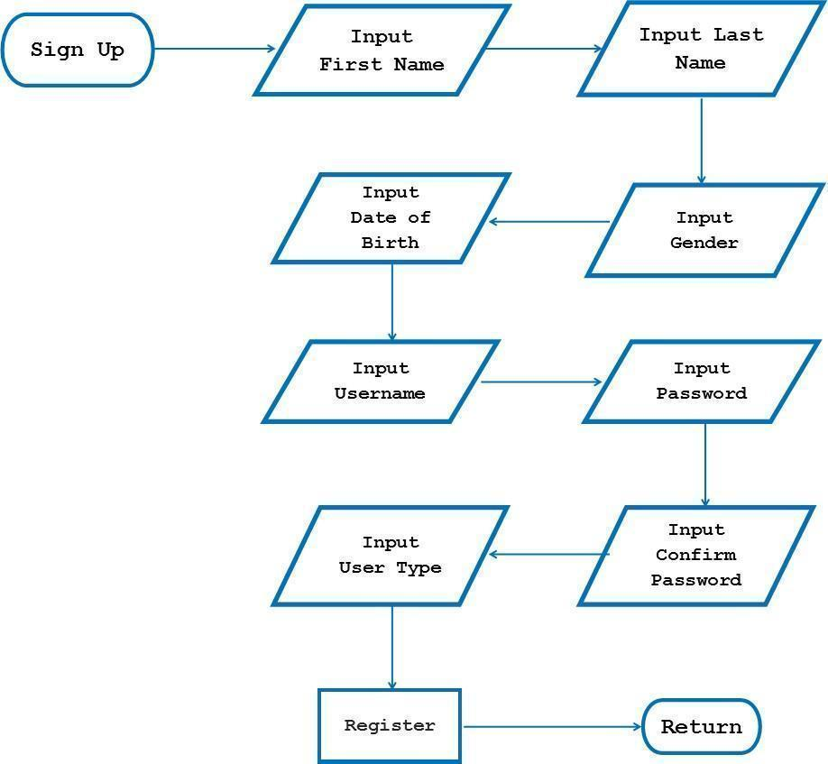

(Cont.)

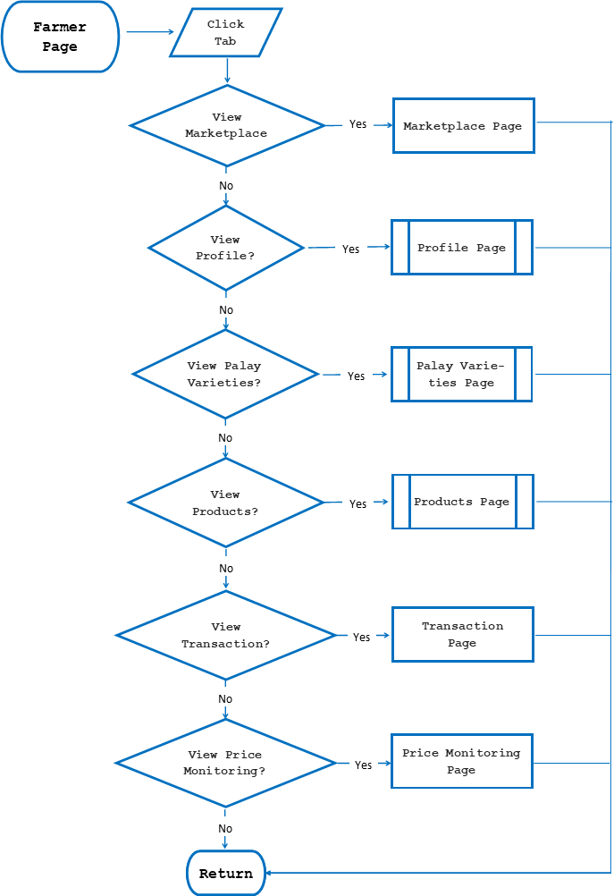

*Figure 7.* Farmer Page

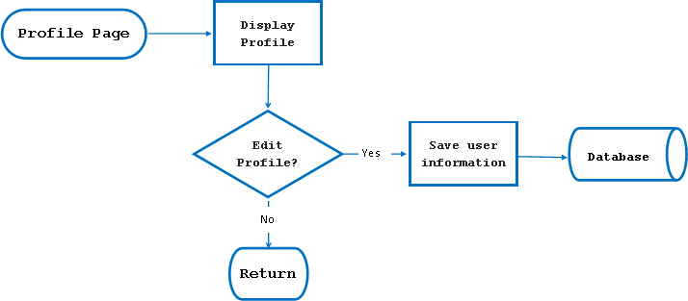

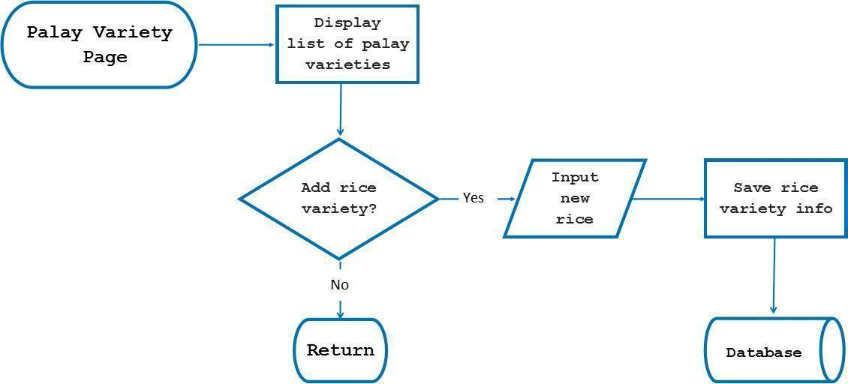

(Cont.)

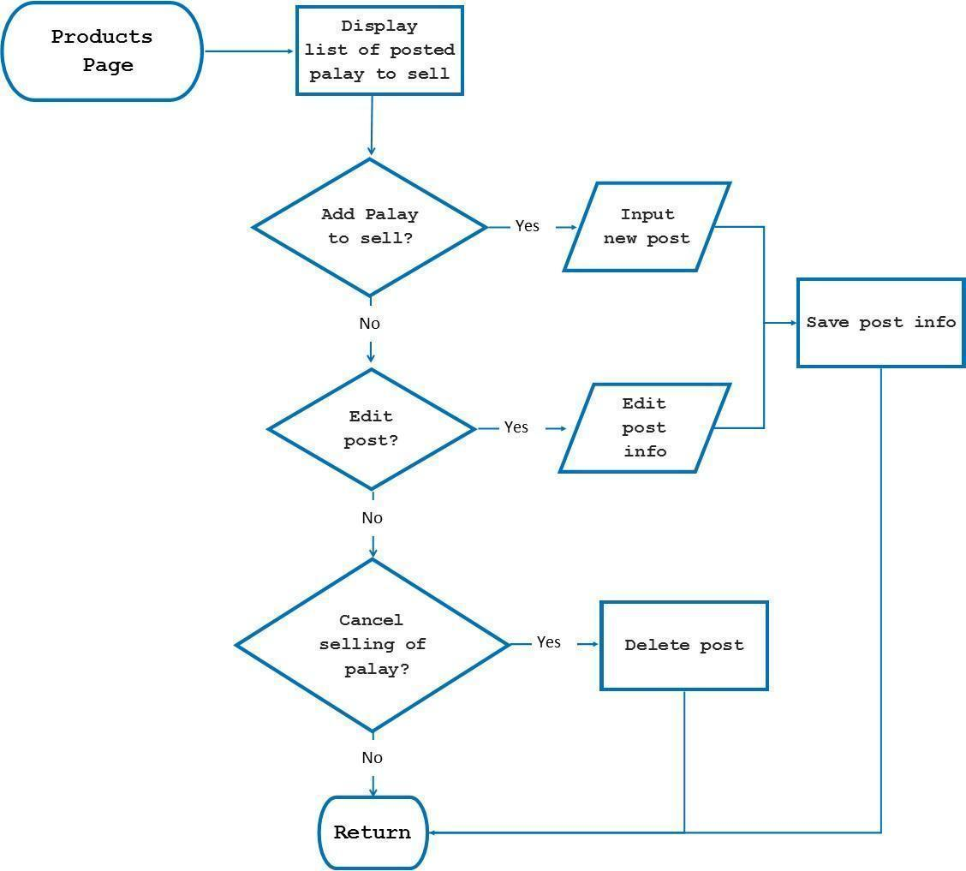

(Cont.)

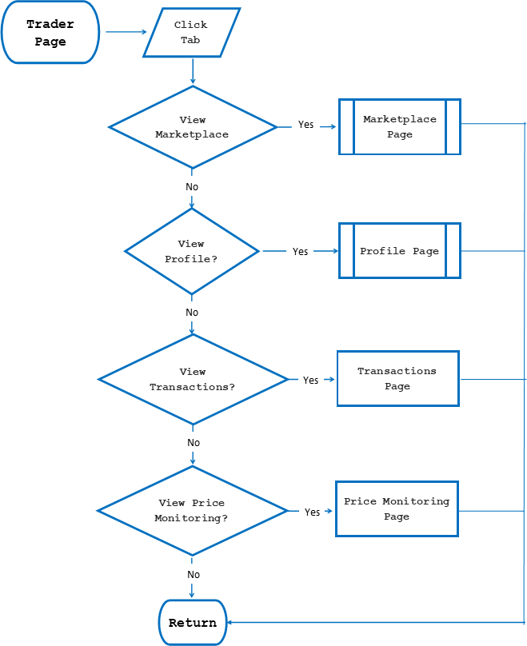

*Figure 8.* Trader Page

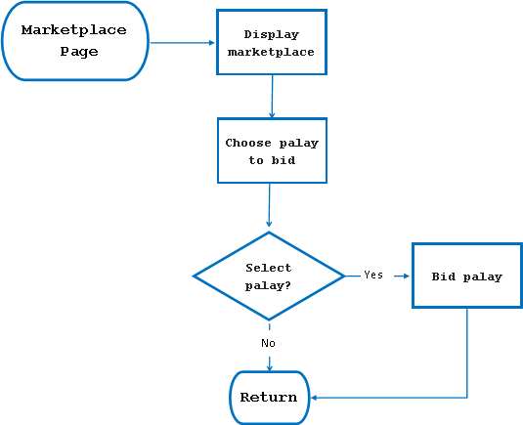

(Cont.)

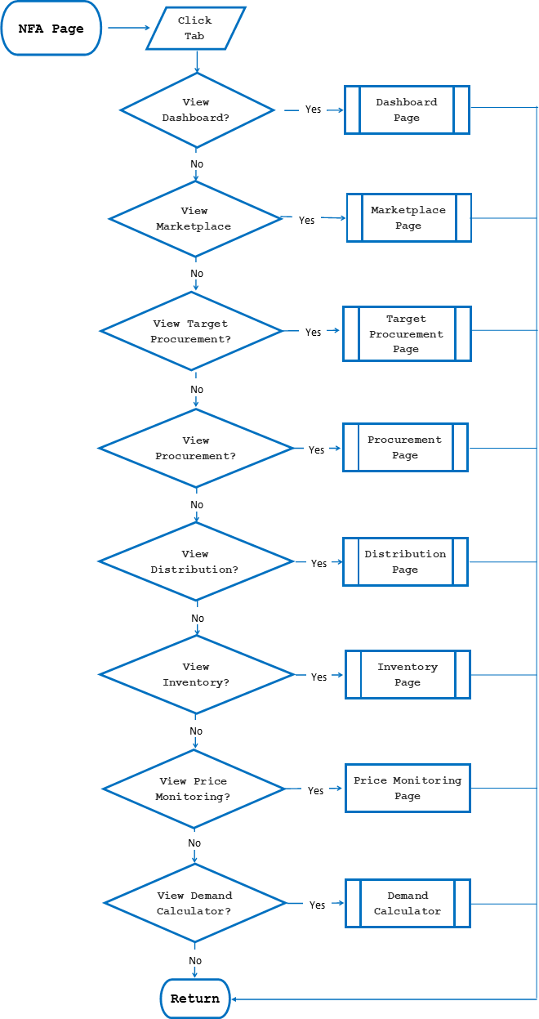

*Figure 9.* NFA Page

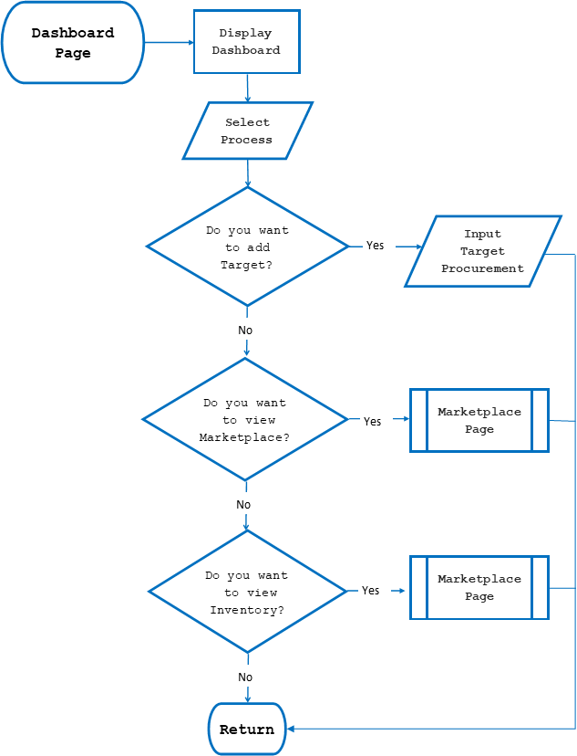

(Cont.)

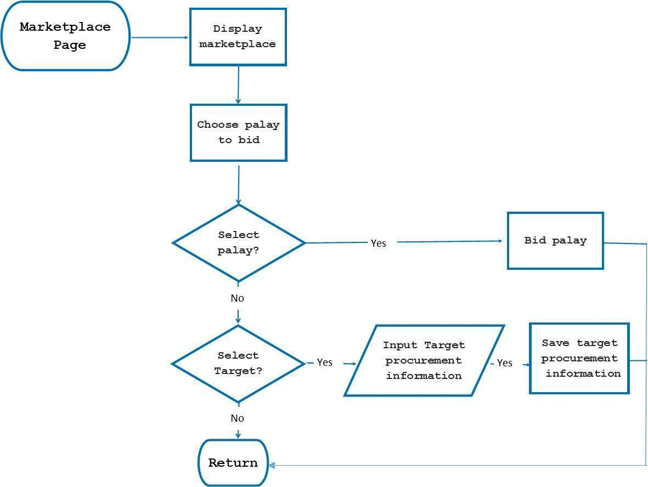

(Cont.)

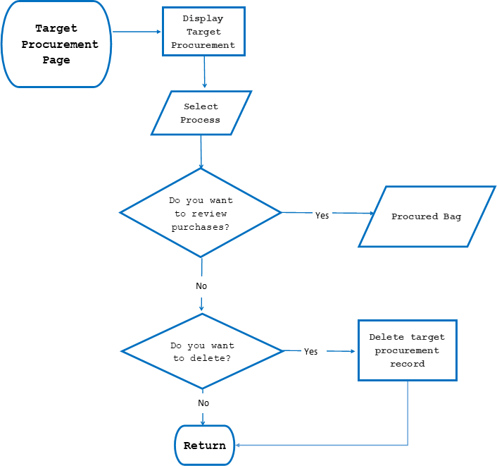

(Cont.)

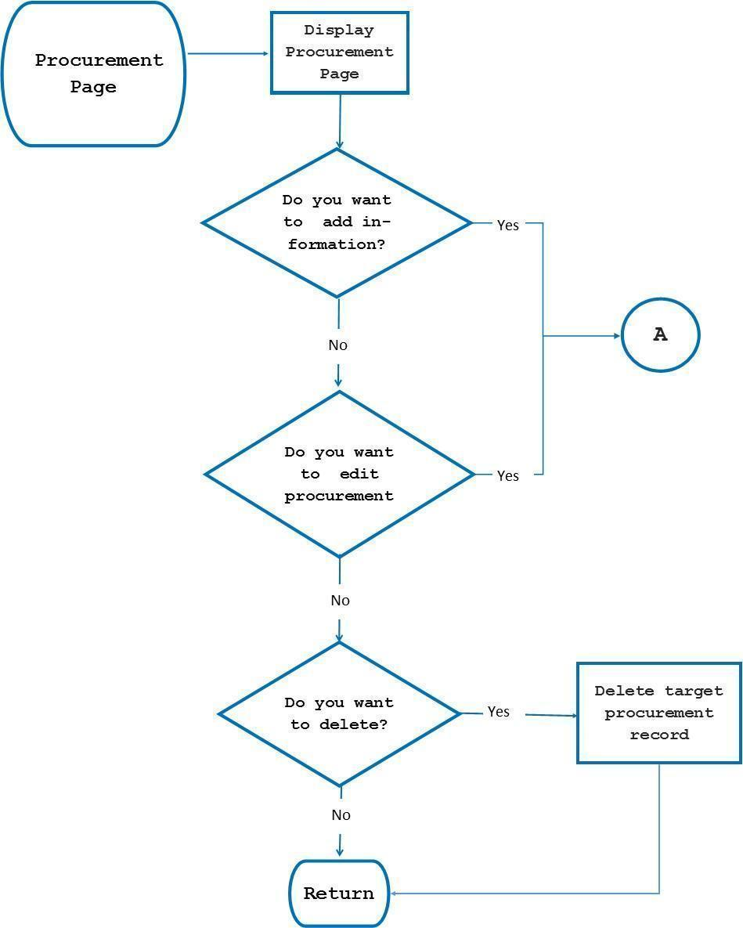

(Cont.)

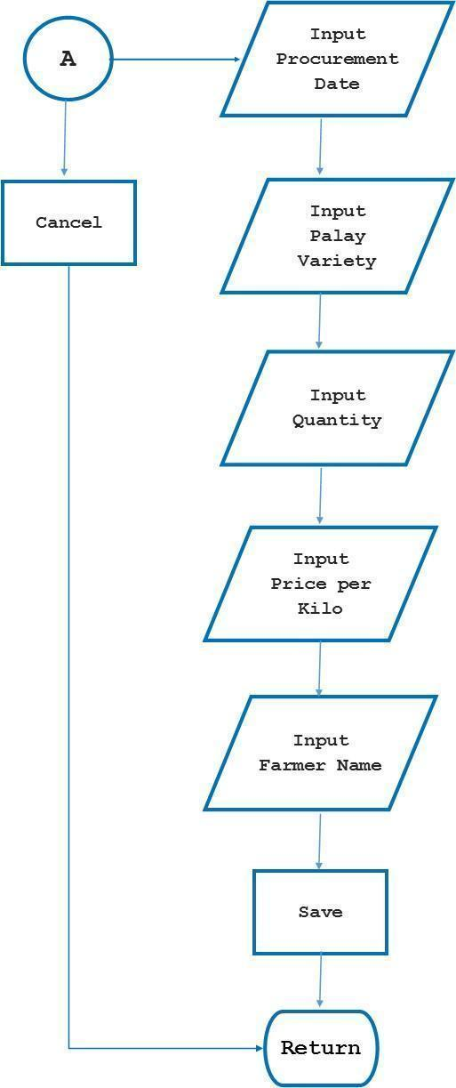

(Cont.)

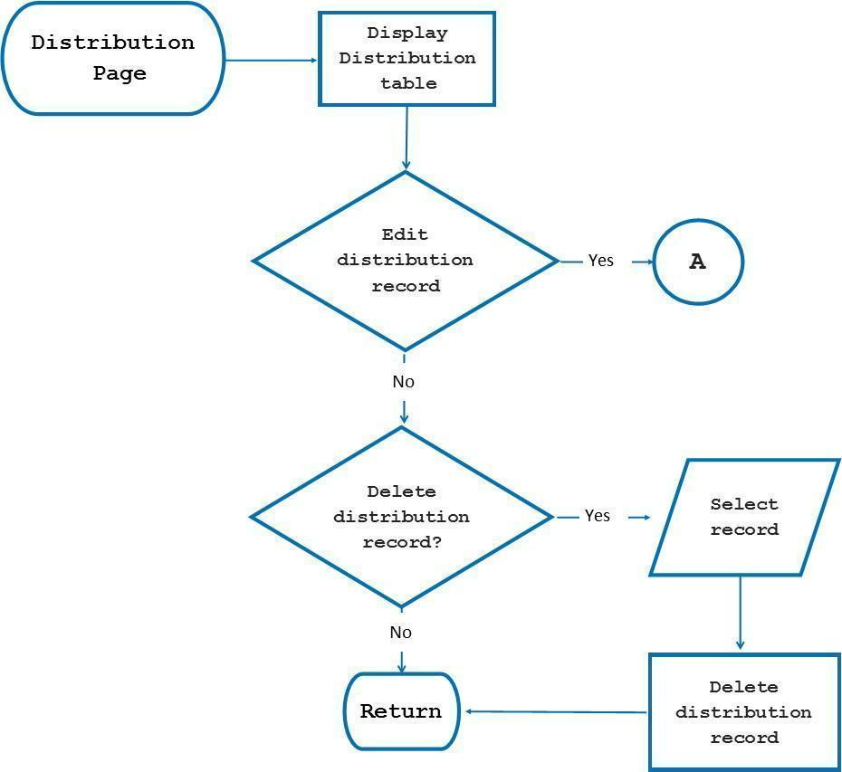

(Cont.)

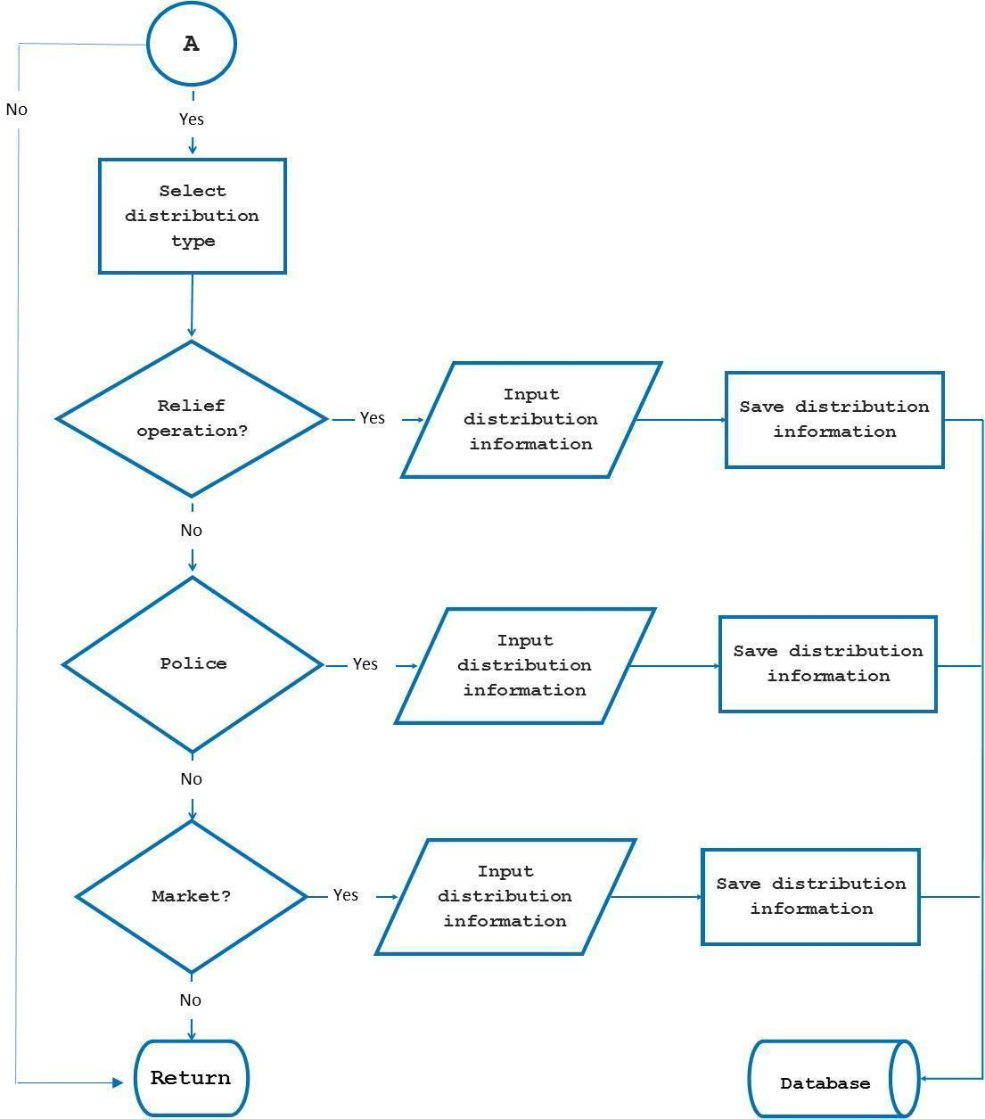

(Cont.)

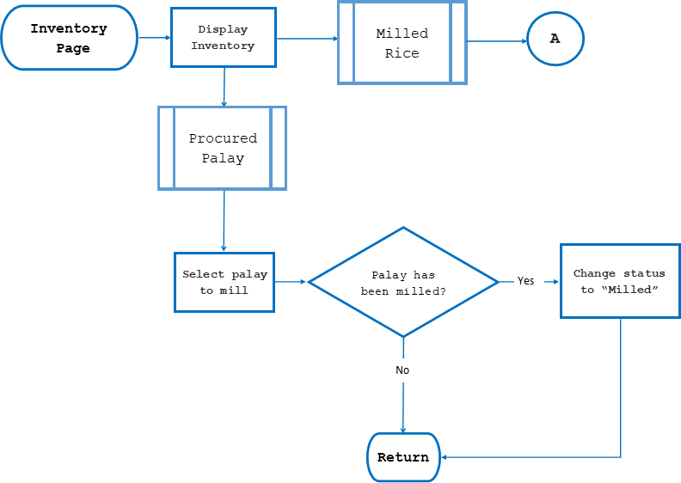

(Cont.)

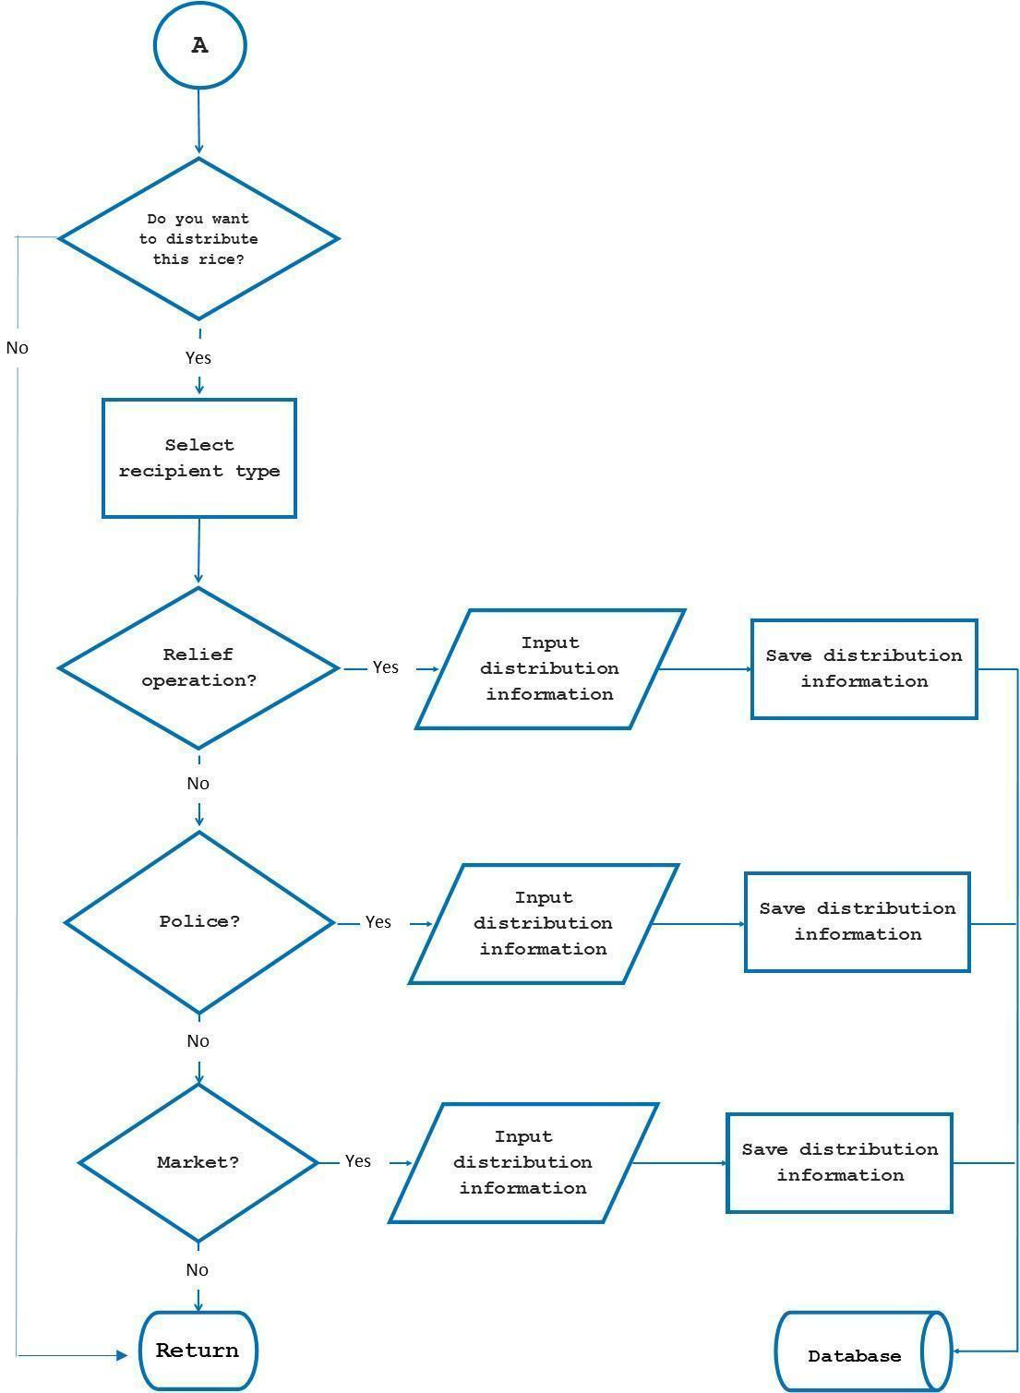

(Cont.)

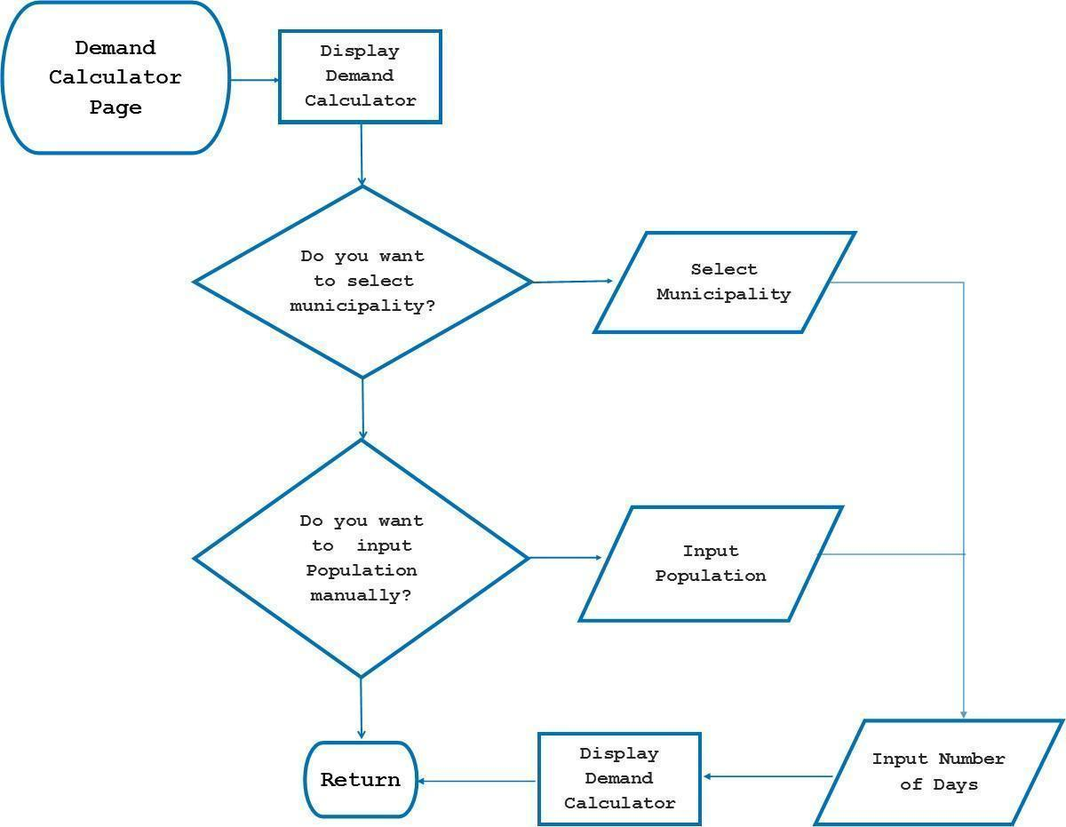

*Object-Oriented Design (UML)*

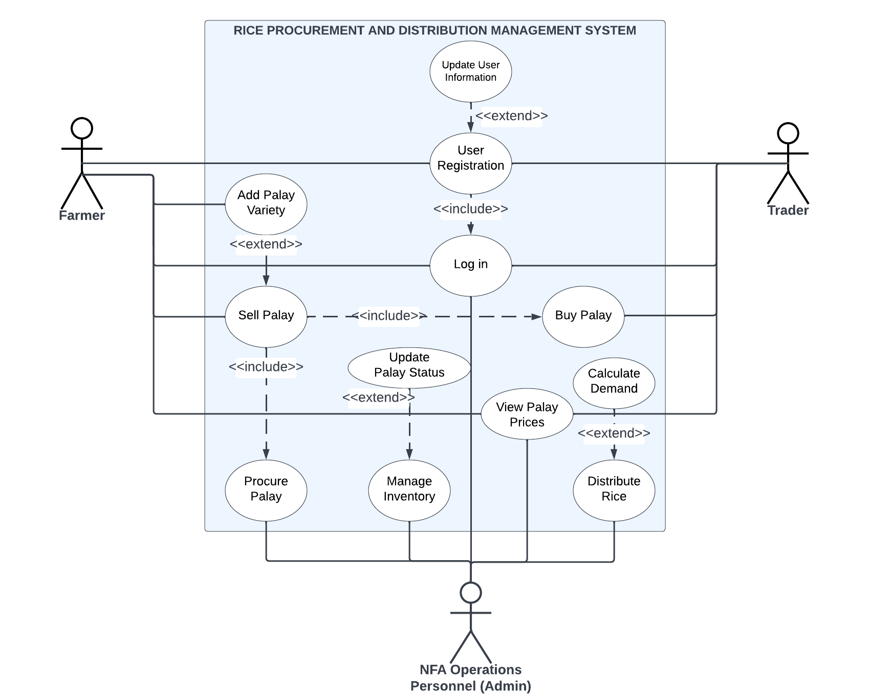

*Figure 10.* UML (Use Case) Diagram of the System

The Figure 10 shows the UML (Use Case) diagram of the system. There are three actors that interact with the system. The farmers and traders are required to register as users for them to log in to the system and these users can update their user information. The farmer can sell palay in the marketplace and add palay variety. The trader can then buy the palay being sold in the marketplace. The NFA (Admin) procures palay from the marketplace, manages the inventory by updating the status of palay if it is milled or distributed following the 3-6-9-month rule, and distributes the rice, when necessary, with the aid of demand calculator to calculate the estimated demand during relief operations. All users can view the prices of palay for monitoring that is based on the successful transactions of farmers and traders.

*Process Design*

This shows the data flow diagram of the management system whereas the system is broken down to another level. DFD shows a management system as a whole and emphasizes the interaction with the entities.

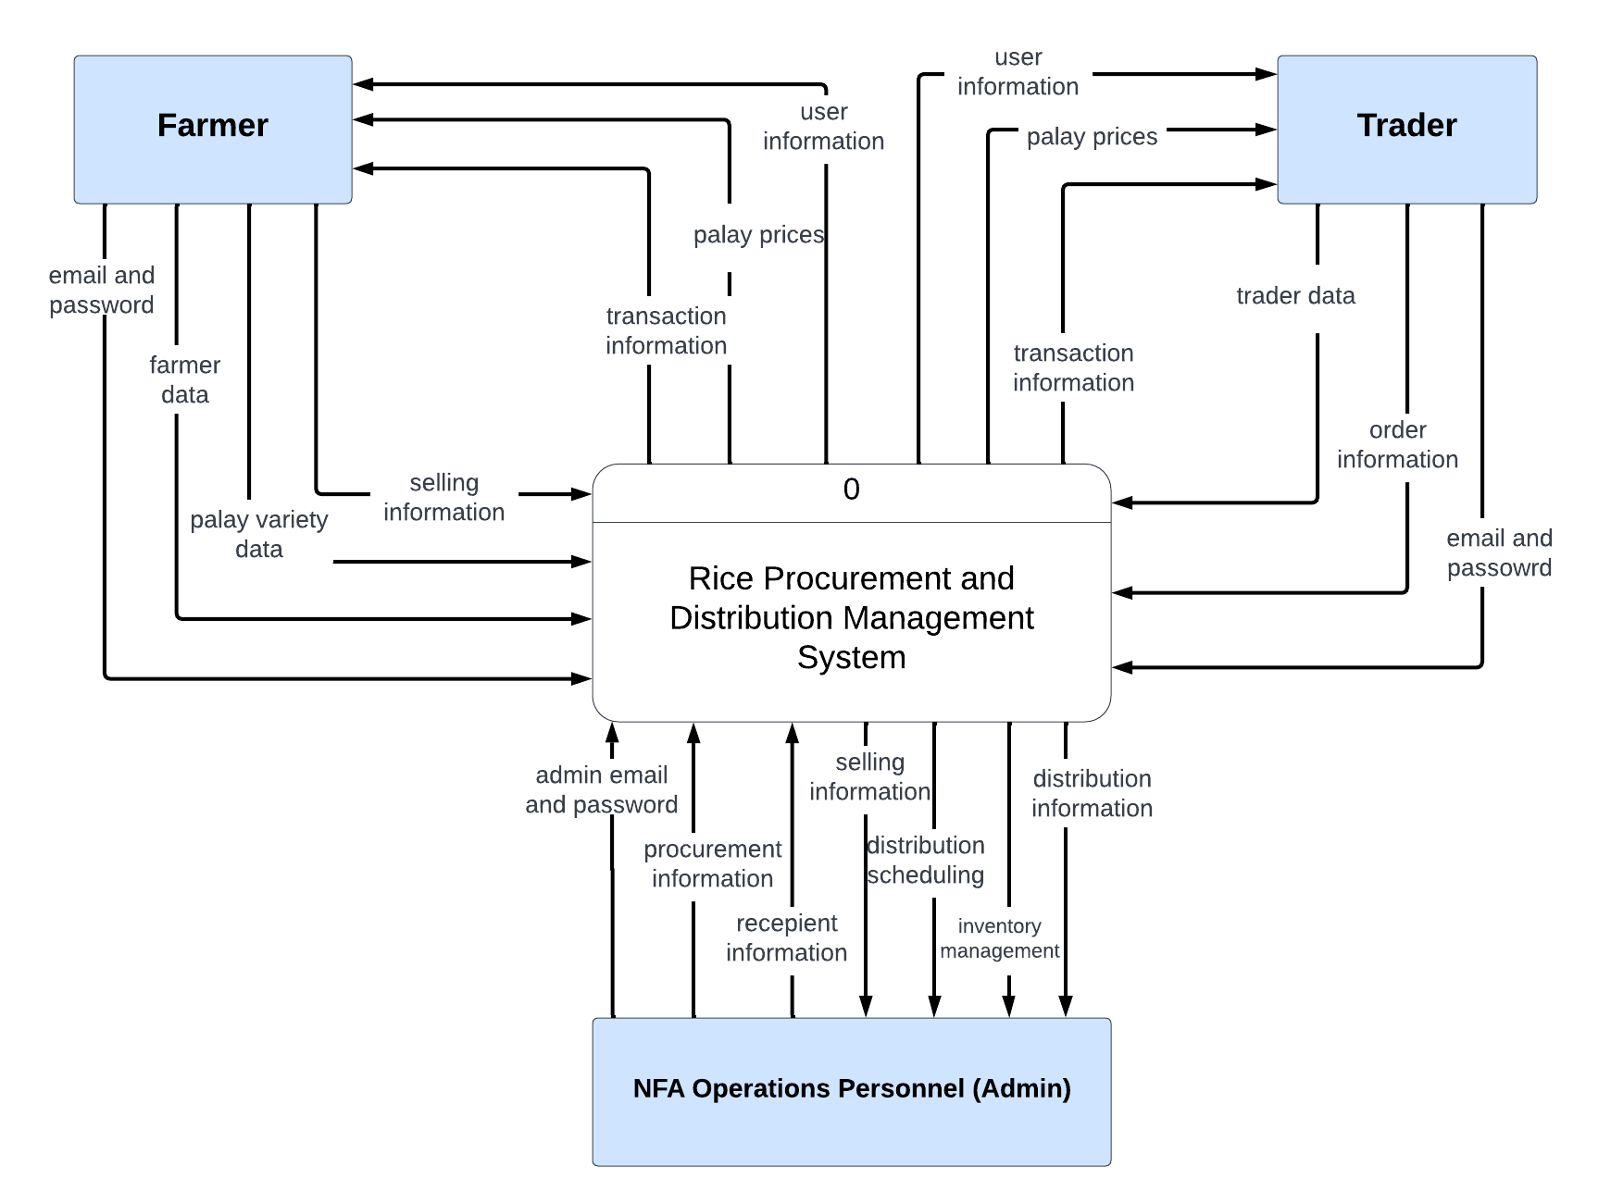

*Figure 11.* Context Diagram

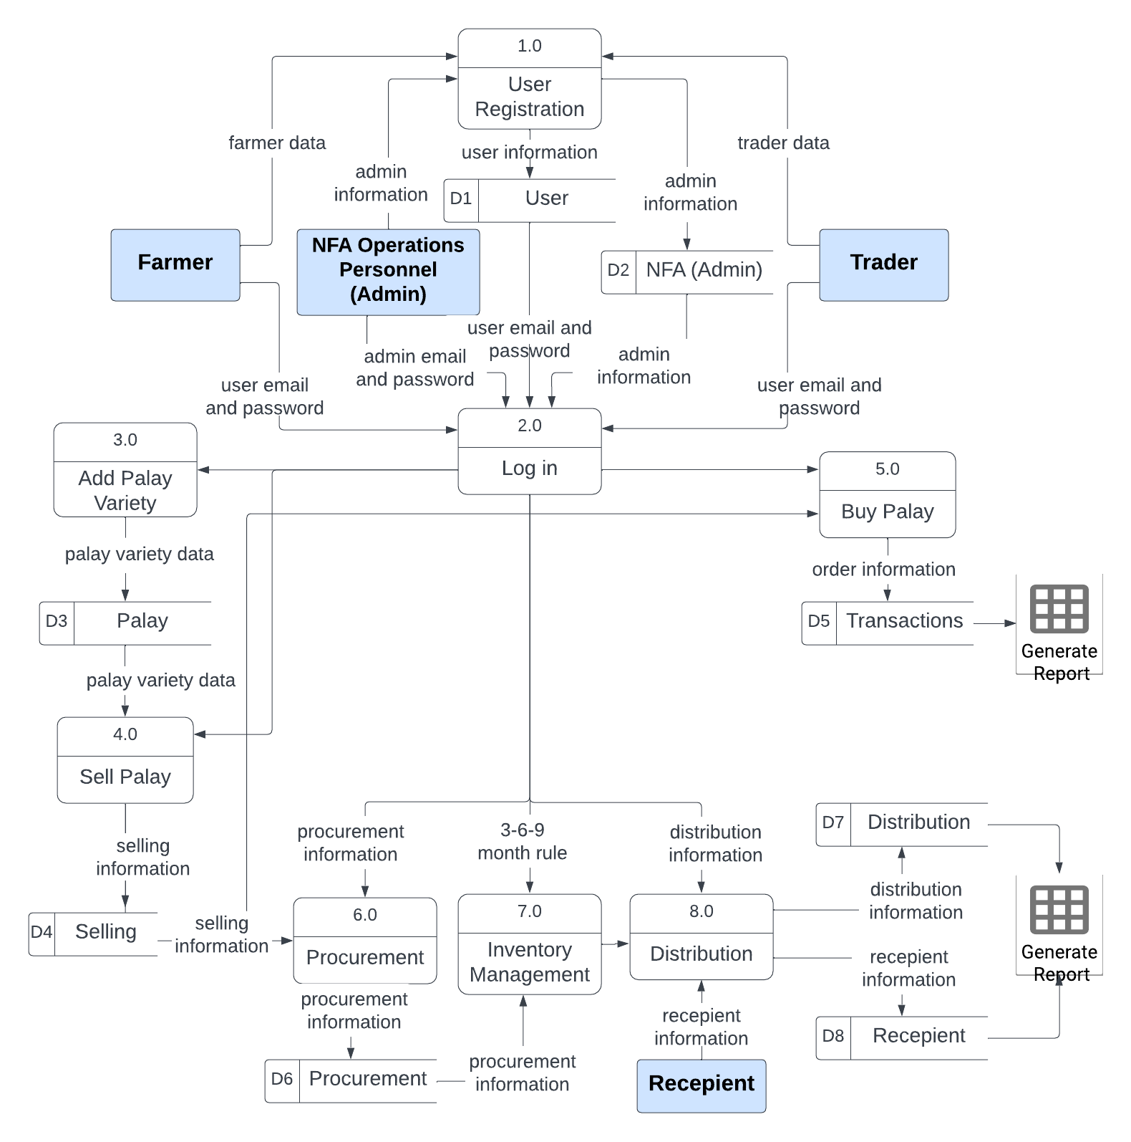

*Figure 12.* Level 1 Diagram

Figure 11 shows the context diagram of the management system whereas the rice procurement and transportation Management system is a process. Context diagrams provide a graphical representation of how the information interacts between the processes in the system. Farmers, Traders, and NFA are the external entities. Wherein, these external entities have the data flow of username and password for their log-ins. The farmers post the number of palay to sell, and the traders see the number of palay to buy. All the procurement and distribution records are saved to the database and the system generates visualization on the dashboard.

*System Development Life Cycle*

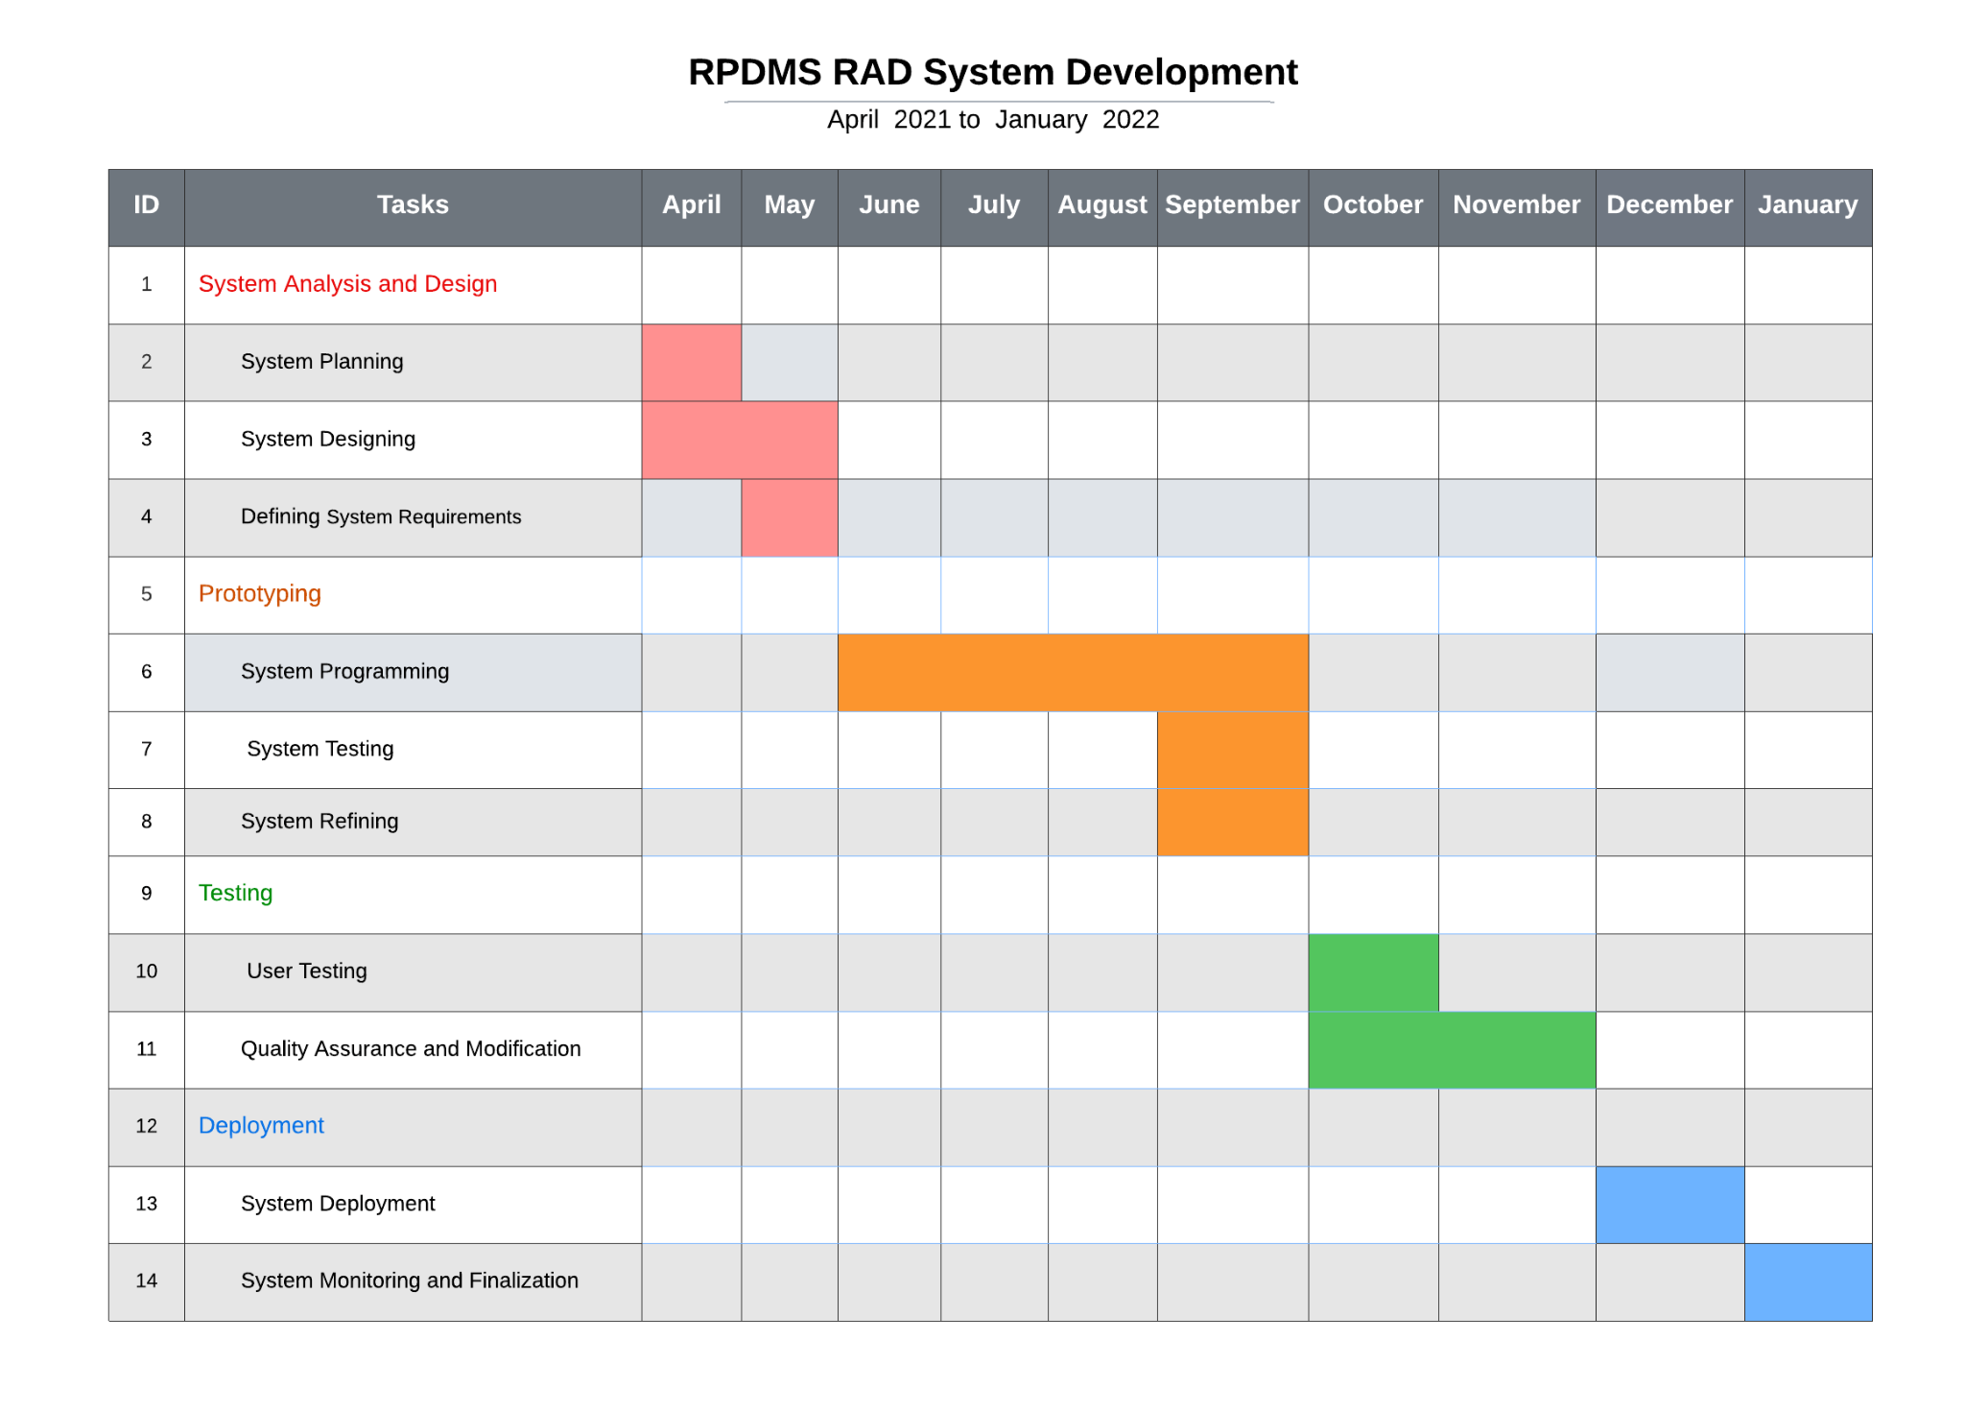

*Figure 13.* RPDMS RAD System Development Gantt Chart

In this study the SDLC - Rapid Application Development (RAD) Model was used in the development of the proposed system. The system’s development had undergone four phases namely: Quick System Analysis and Design, Prototype Cycle, Testing, and Deployment.

The first phase is Quick System Analysis and Design. It involves system planning, system designing, system requirements, and system architectures are made. The   
researchers identified the National Food Authority was the targeted organization of the researchers. The researchers studied and identified the flow of information and distribution of information in different channels between the farmer, traders and NFA. A complete business analysis was performed to find important information in creating documents and forms and how the processes will flow. The information gathered is analyzed to form data objects for the NFA. The data object sets will be used and converted to establish the NFA flow of information needed to achieve specific objectives.

The second phase is the Prototype Cycle. This is where the researchers built, tested and refined it. In this stage includes System Programming, Integrating, Testing Researchers have finalized the content of the database and added the features and functions in the interface of the system.

The third phase is the Testing phase. This is where the researchers deploy the prototype of the system for user testing, quality assurance and modification. This includes testing the entire system and correcting the system’s problems. The researchers identified that the NFA is lacking a system and they were looking for a system that can improve their efficiency and fast-moving system. Like in procurement, distribution, and inventory. In this phase, the researchers will now test the proposed system for the functionality of the marketplace, procurement and distribution and integration of the 3-6-9 model of NFA in managing the inventory.

The last phase is Deployment. In this phase, the researchers will now deploy the output of the project.

CHAPTER 4 Results and Discussion

Implementation

The system is implemented to connect three out of the actors in the rice value chain in the Philippines which are the farmers, rice traders, and NFA through a marketplace where palay trade can be done. It also integrated some organizational processes of NFA for them to have a more systematic operations management. The researchers had trouble in managing the number of functions of the system that the transportation scheduling of palay delivery was eliminated. The system is also supposed to have a forecasting capability for the palay procurement and rice distribution but the available data from the NFA are limited and aggregated with monthly data granularity. This led the researchers to focus on the operations management aspect of the NFA. By identifying and understanding the main operation processes of the NFA through interview, the researchers have successfully streamlined those processes and integrated them into the system.

The development of the system went successfully through the help of four phases of Rapid Application Development (RAD) Model which are: quick system analysis and design, prototyping, testing, and deployment. The researchers first came up with the main functions and features of the system to identify the processes involved and how the users would interact with the system. The researchers used JavaScript programming language, React JS, and Firebase to develop the system. The researchers created the marketplace first, which is the common feature for all the user types before creating the other functions of the system. The system went through multiple iteration and testing to refine its functionality that meets the set objectives.

It is then subjected to user evaluation by having users from farmers, traders, and NFA to use and assess the system. The researchers start the operation by allowing a Farmer to log in to an account that is used to post a palay that wants to sell in the marketplace. The posted palay can be then bought by traders or NFA by bidding. The farmer can select who to sell to the palay to finish the transaction. This transaction will be recorded and viewed by the farmer and trader on their transaction page while it can be viewed by the NFA on the procurement page. The records on the procurement will also reflect on the inventory where the NFA can track the age of the palay and be notified if it needs to be milled and distributed. The data recorded is used for visualization on the dashboard and know their progress.

*System Inputs and Outputs*

The following figures are the screenshots of the system.

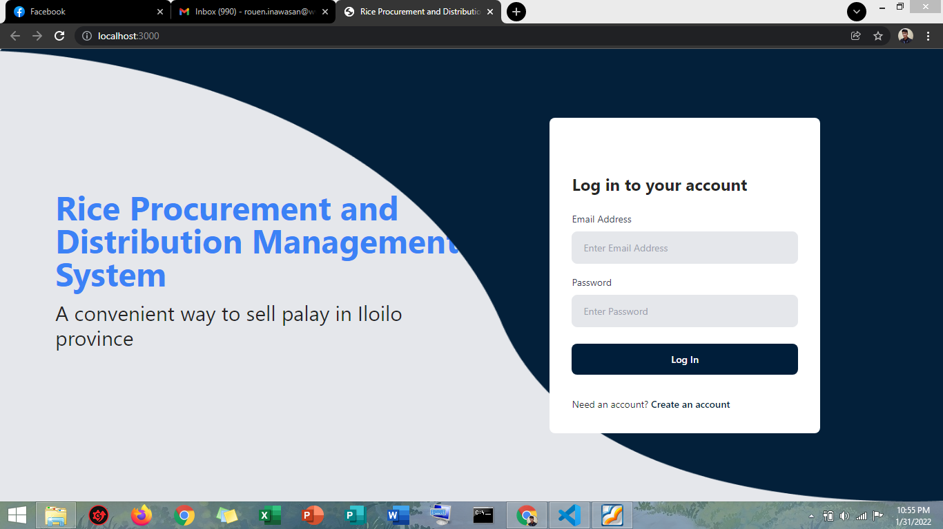

*Figure 14.* Landing Page of the System

Figure 14 shows the Landing Page of the system and the login page.

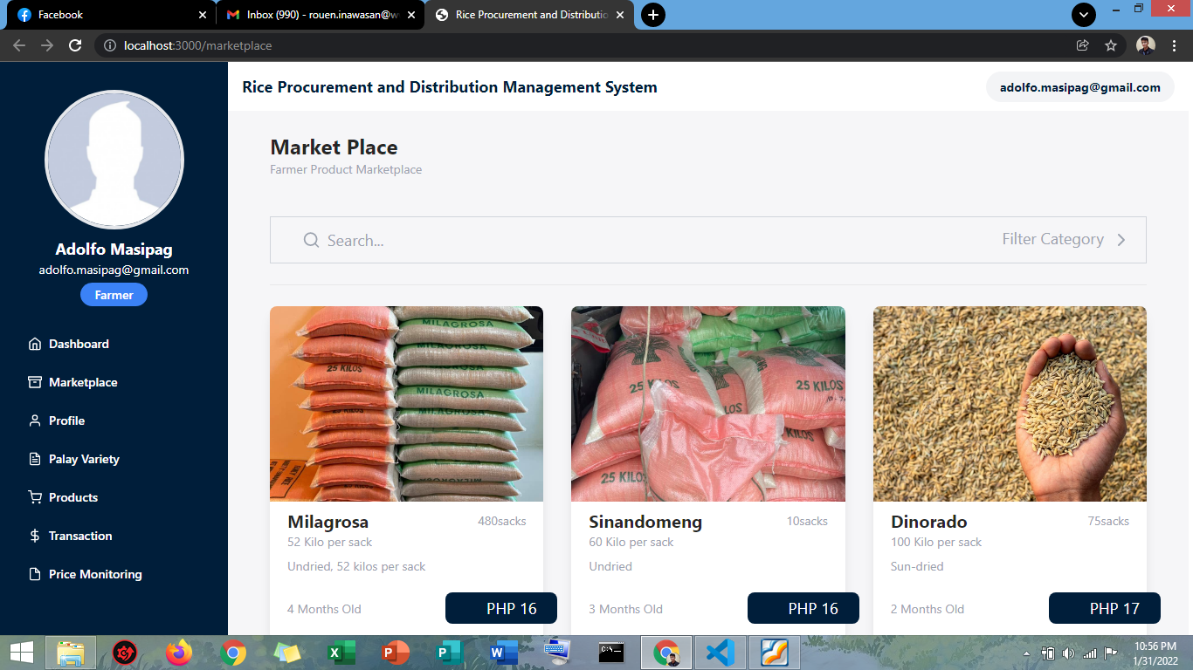

*Figure 15.* Landing Page of Farmers

Figure 15 shows the marketplace where users can view different palay that farmers sell.

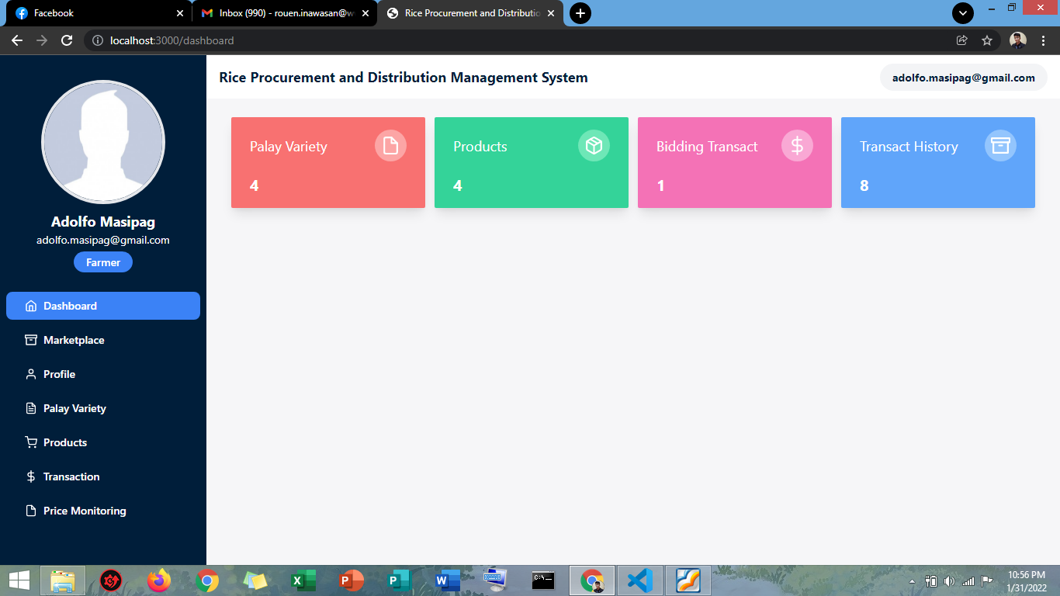

*Figure 16.* Dashboard of the Farmer

Figure 16 shows the total palay variety farmers have, total product posted in the marketplace, total bidding transaction; who bid their product and total transaction history; who have successful transactions.

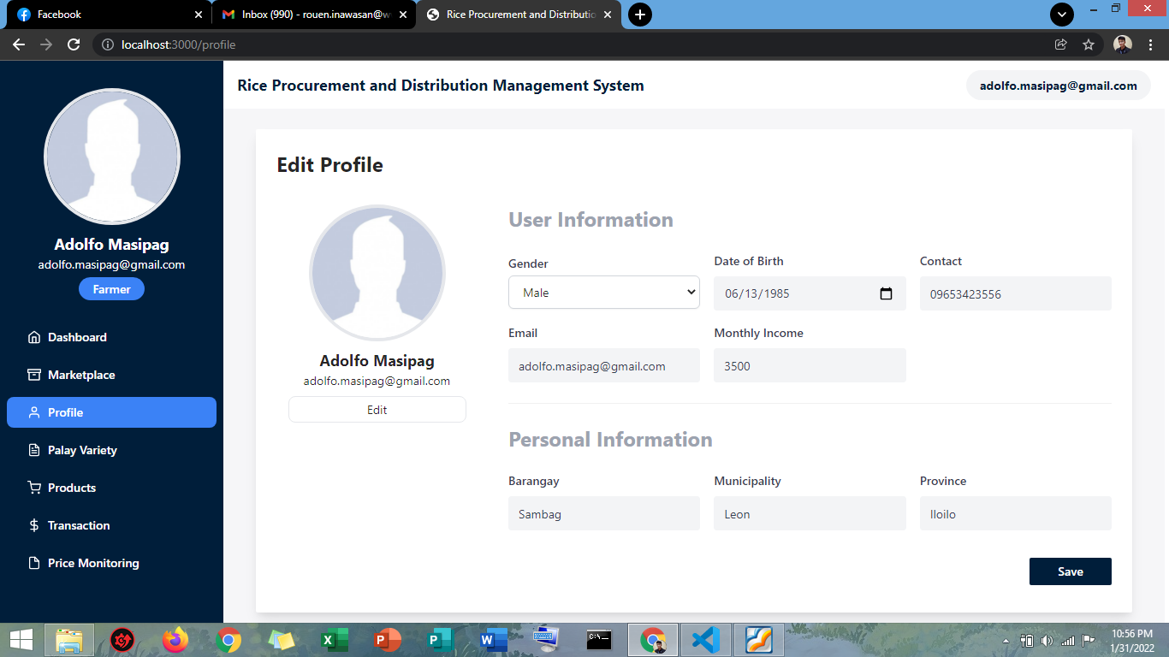

*Figure 17.* The Profile Page of Farmer

Figure 17 shows the user's personal information, whereas users can update and edit their information.

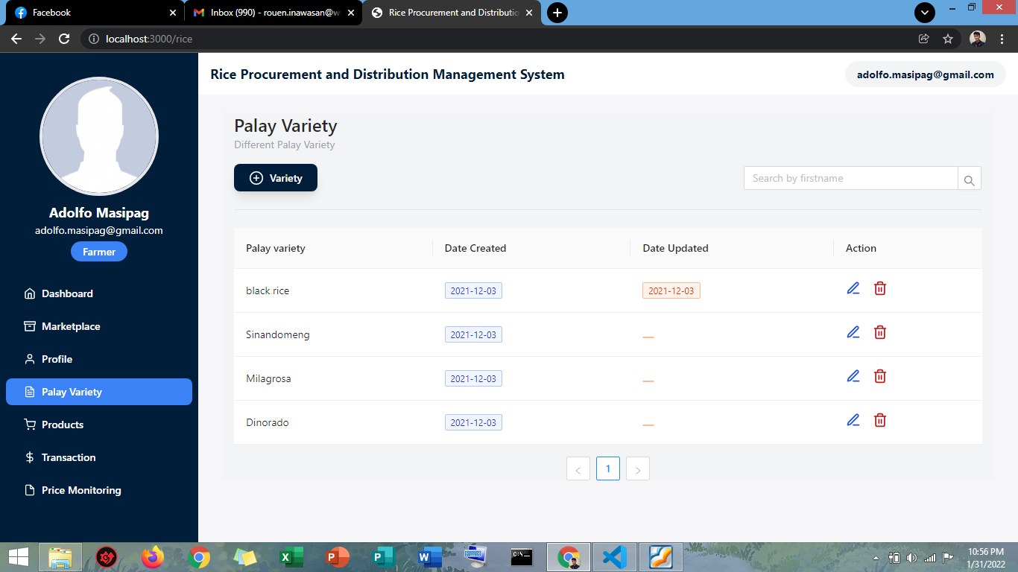

*Figure 18.* The Palay Variety Page

Figure 18 shows the different palay varieties. In this page farmers can add, edit, and delete palay varieties.

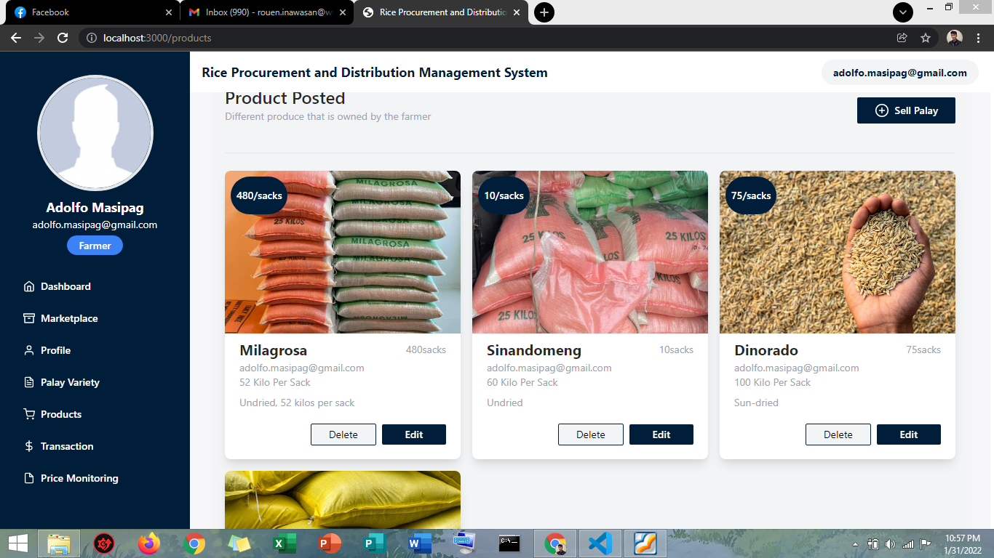

*Figure 19.* Products Page

Figure 19 shows that users can view the products that are posted in the marketplace, in that page, the farmer can edit and delete their product.

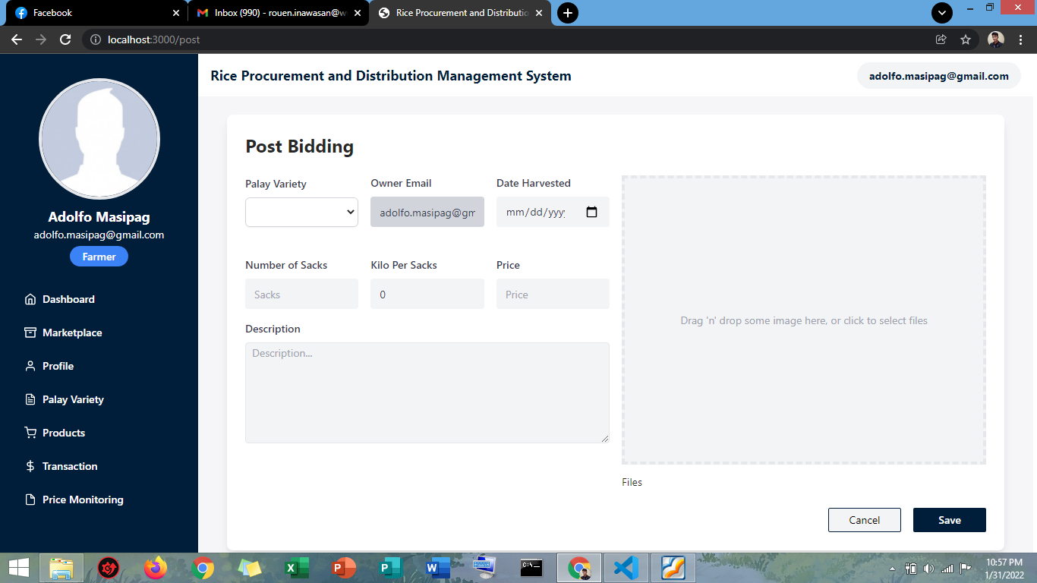

*Figure 20.* Post Bidding Page

Figure 20 shows the page where farmers enter the details of their produce and after they save it will automatically post their produce.

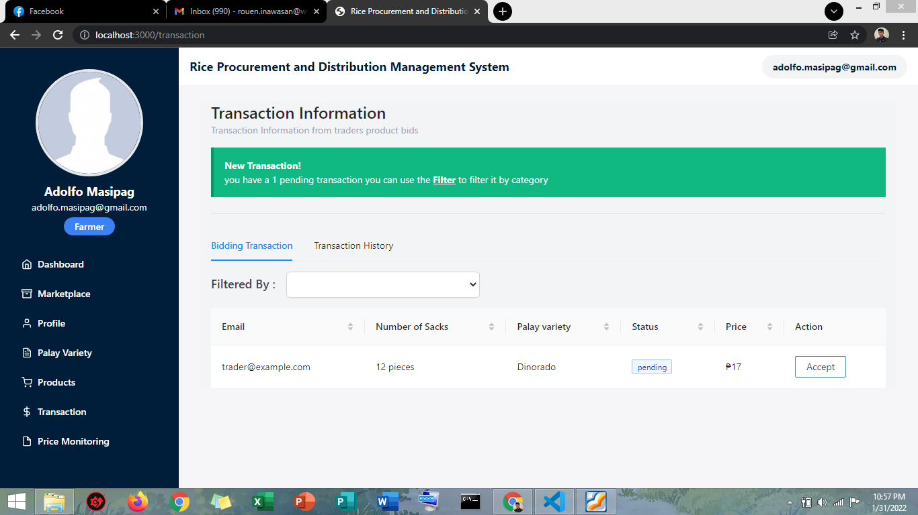

*Figure 21.*Transaction Page of Farmer

Figure 21 shows the bidding history and the transaction history.

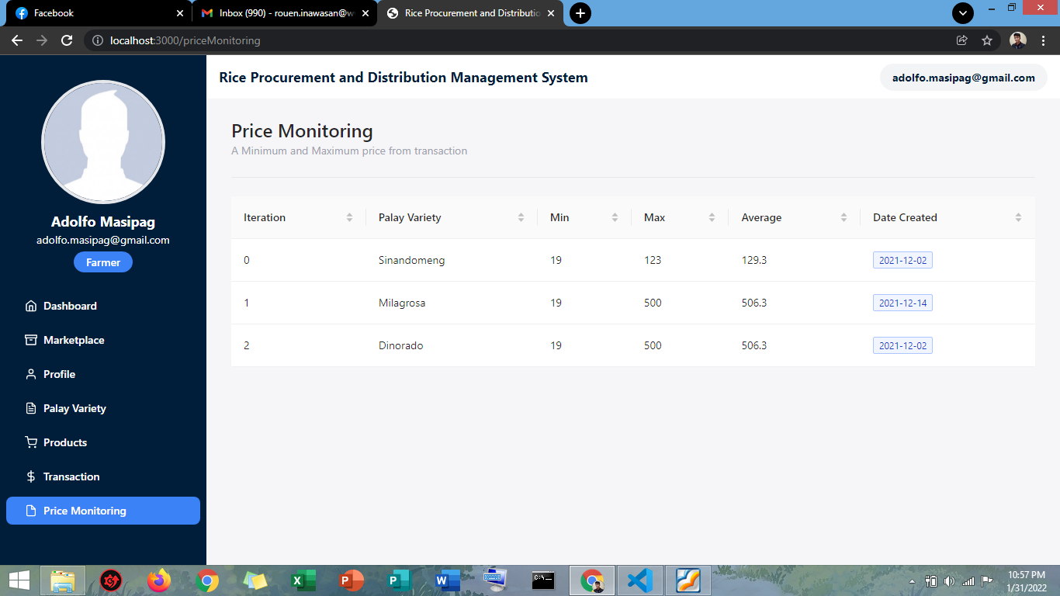

*Figure 22.* Price Monitoring Page

Figure 22 shows the minimum and maximum price of transaction per variety. The purpose of this page is to

determine the average price of product per variety in every successful transaction.

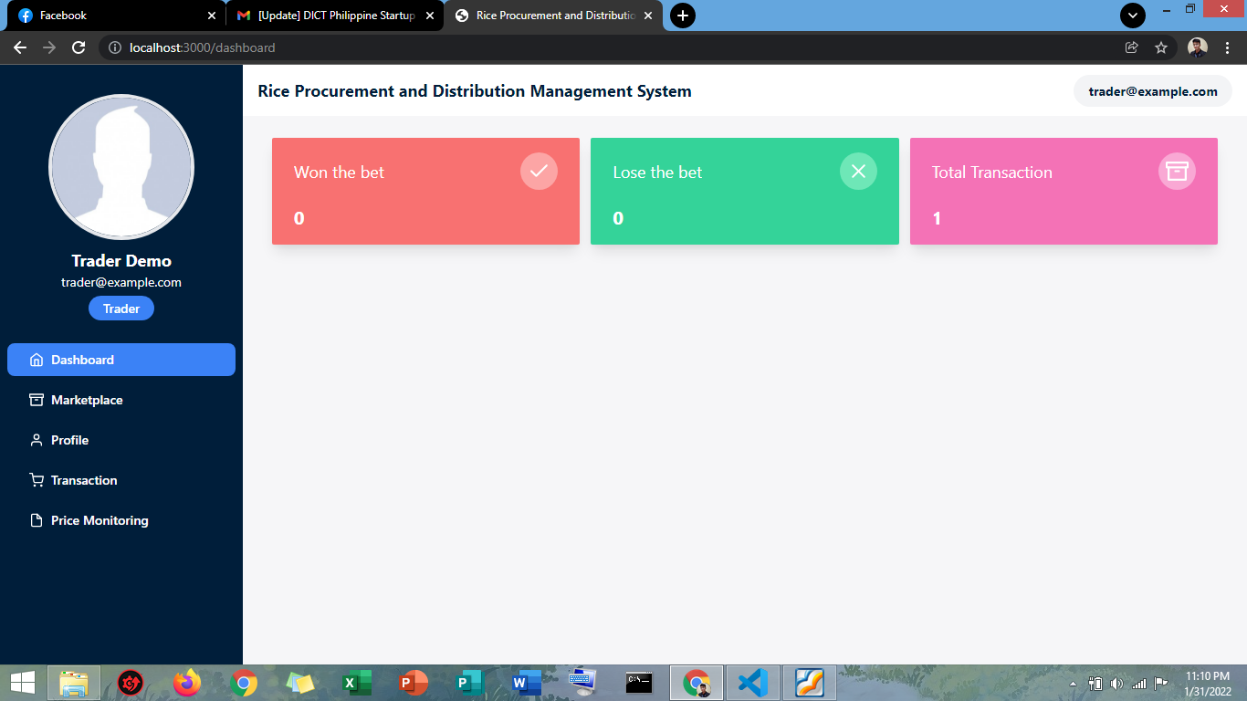

*Figure 23.* Dashboard of Trader

Figure 23 is to visualize the total number of won bids, total number of lose bids and total transaction traders have.

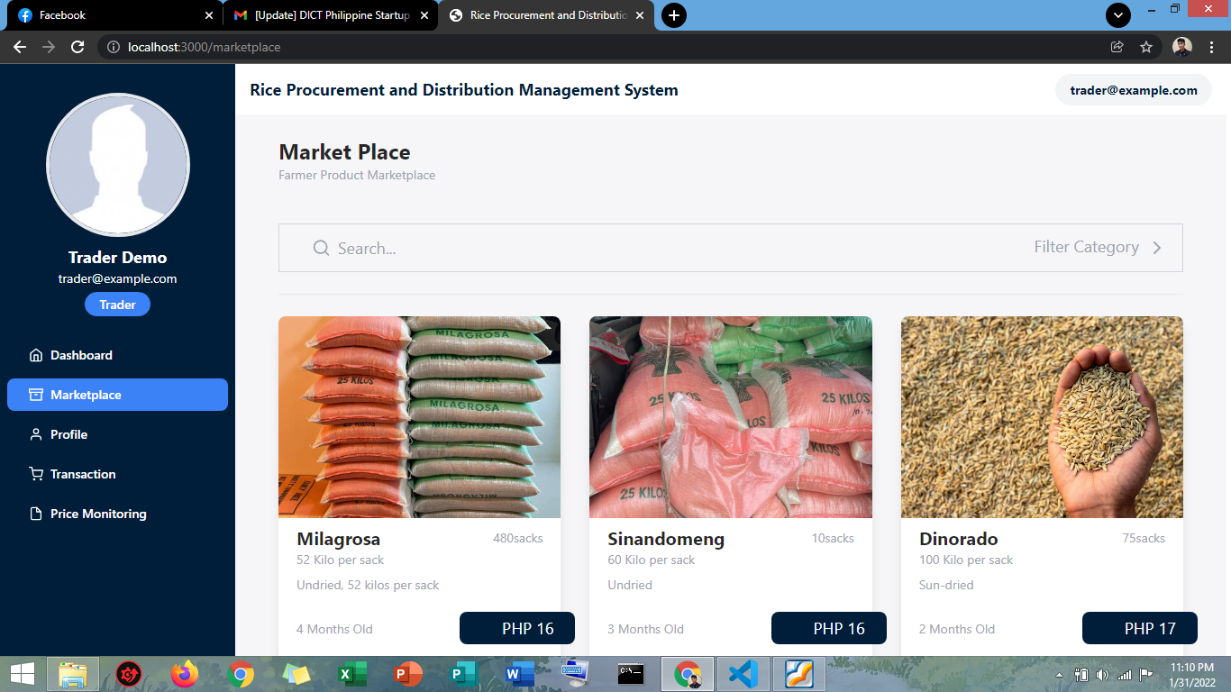

*Figure 24.* Marketplace of Trader

Figure 24 shows the product of all farmers where the trader can select palay to bid.

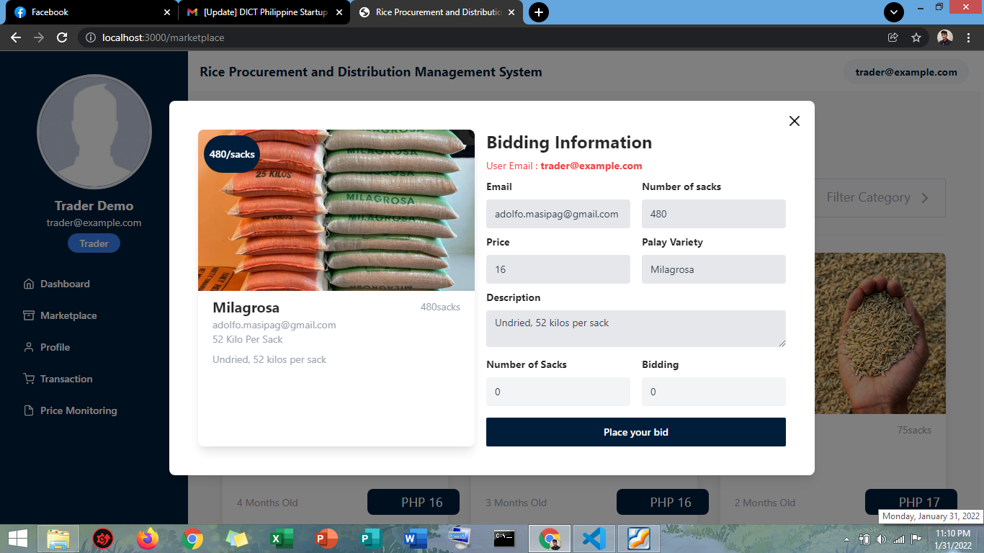

*Figure 25.* Trader’s Bidding Page

Figure 25 shows the bidding information page where the trader can place their bid.

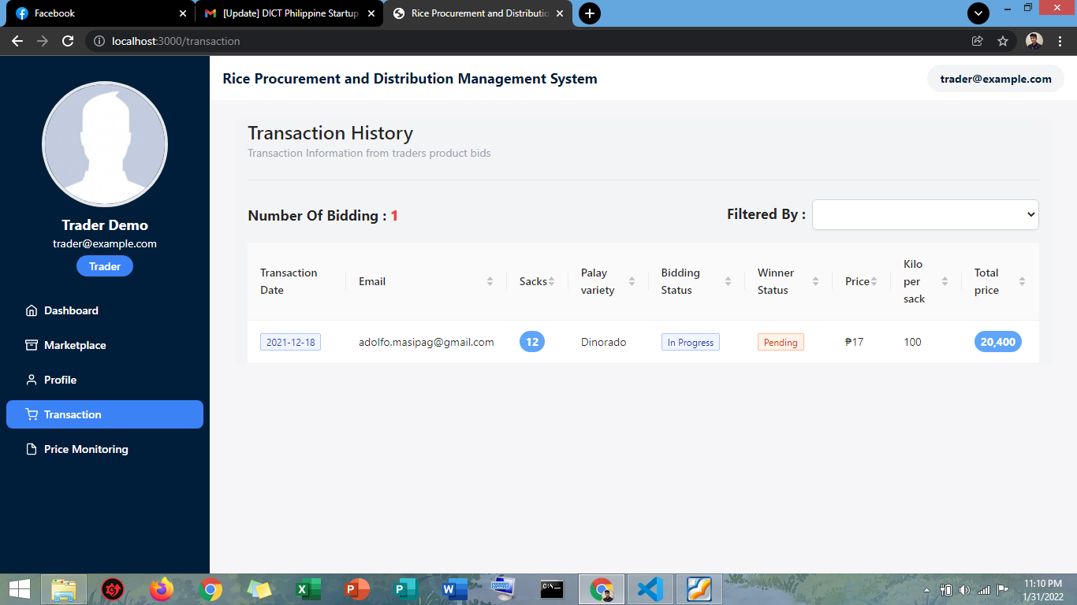

*Figure 26.* Transaction Page of Trader

Figure 26 shows all the products that traders bid on the marketplace whether it was accepted or still pending.

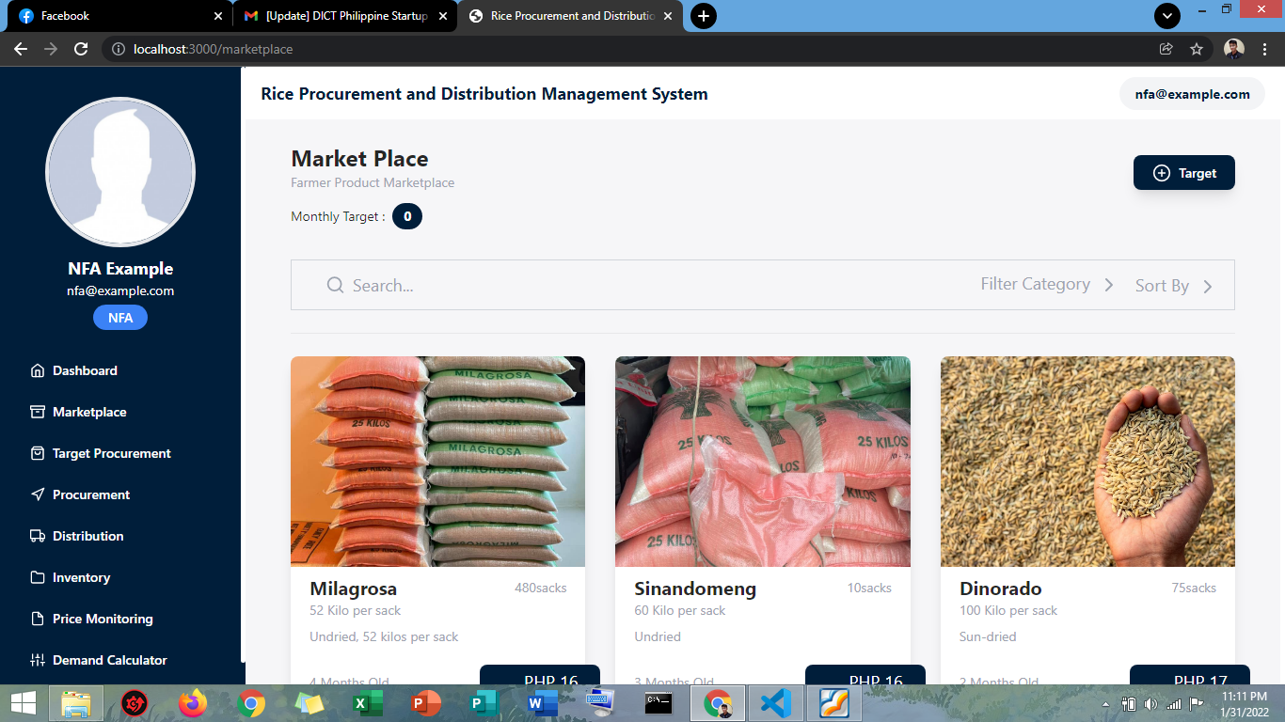

*Figure 27.* Marketplace of NFA

Figure 27 shows the marketplace, every time the NFA signs in, they will be redirected to the marketplace, where they can select farmers' products and bid.

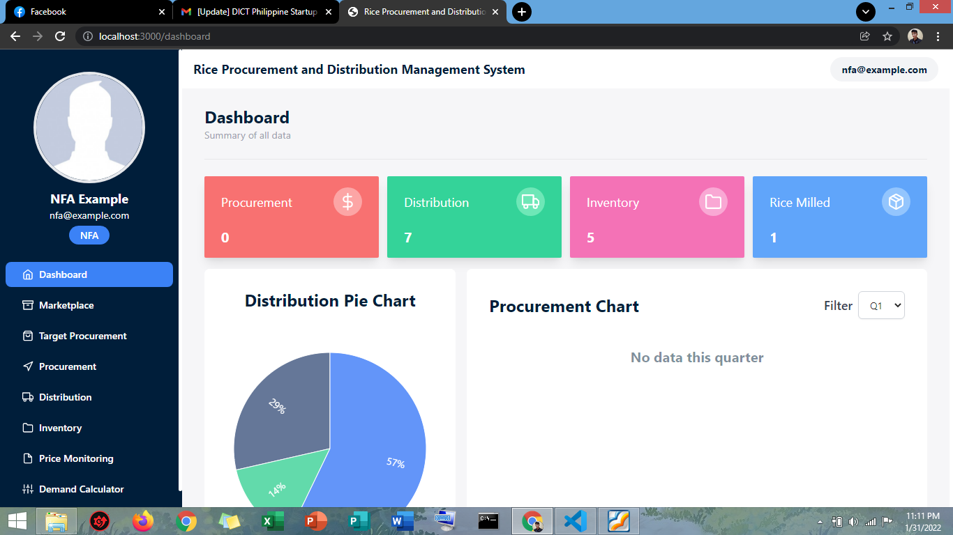

*Figure 28.* Dashboard Page of NFA

Figure 28 shows the total procurement, distribution, total inventory, and total rice milled. The use of this page is to visualize the data that has been procured,

distributed and the inventory to monitor the buffer stocks.

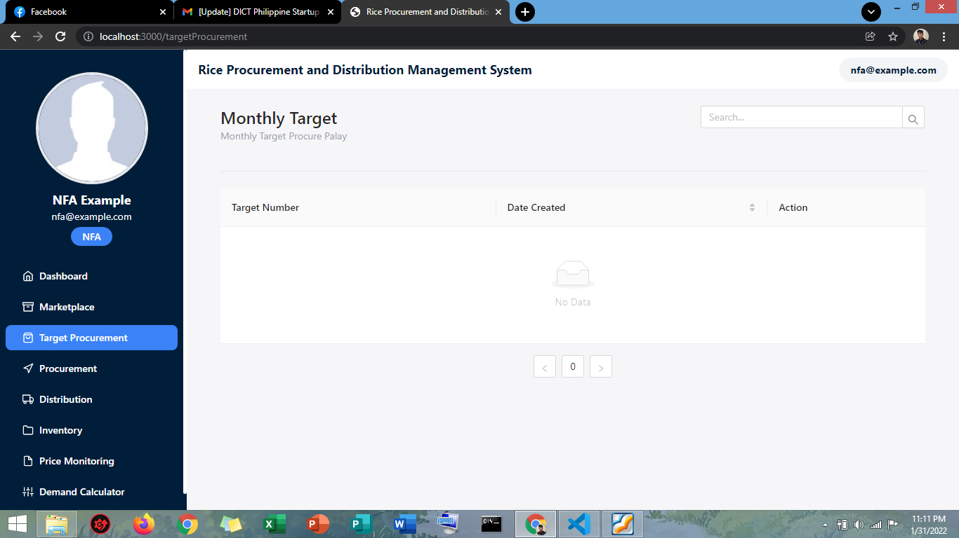

*Figure 29.* Target Procurement Page of NFA

Figure 29 shows the monthly target procurement. It is used to identify and differentiate monthly targets NFA have in a year.

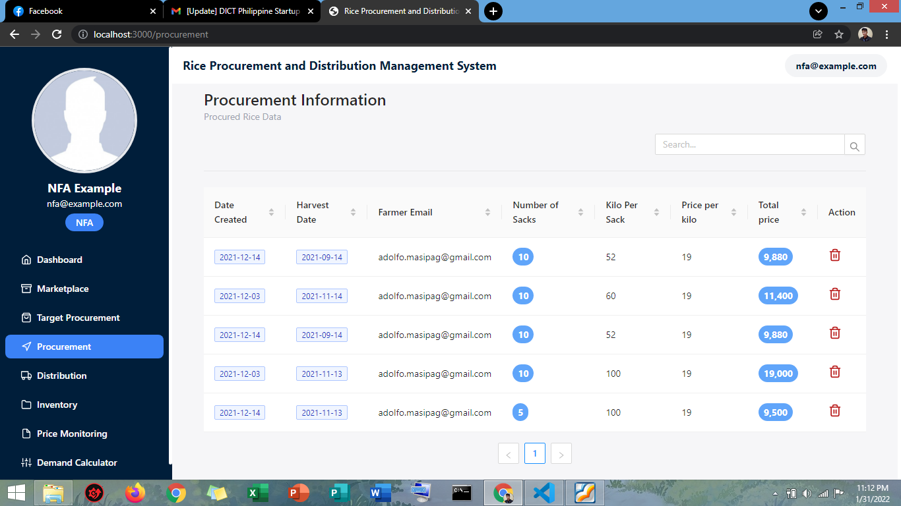

*Figure 30.* Procurement Page of NFA

Figure 30 shows the procured palay from the farmer. The record is automatically added to the inventory and also visualized in the dashboard.

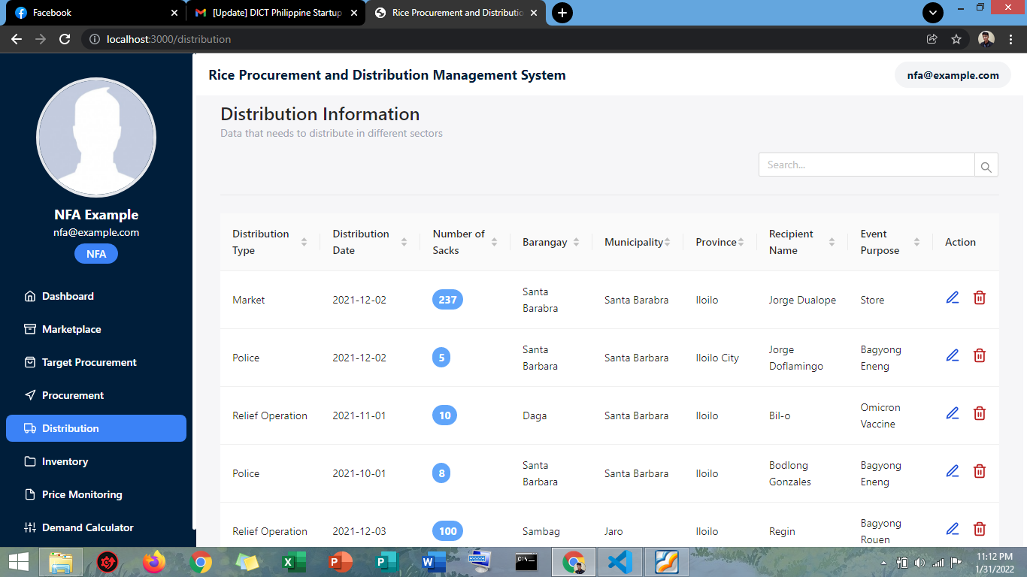

*Figure 31.* Distribution Page of NFA

Figure 31 shows the distribution data of NFA. There are 3 categories of distribution: the Police supply, relief operation and market. The data in the distribution page are visualized in the dashboard to easily analyze the data.

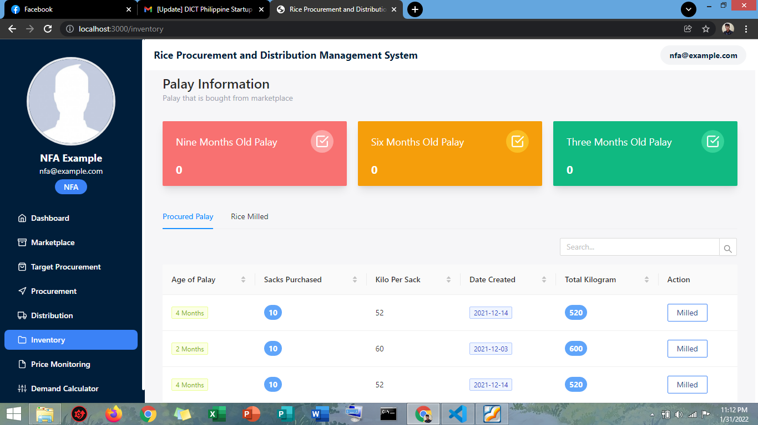

*Figure 32.* Inventory Page of NFA

Figure 32 shows the 3,6,9 rules of the NFA. In three (3) months, the palay should not be more than 3 months old from the date harvested. Six (6) Months, the palay should be milled on or before 6-month-old from the date harvest. 21 Nine (9) months, the rice milled should be distributed on or before 9-months-old from the date milled. Every time the NFA procure a palay to the farmer the data is automatically added to the inventory under the procured palay table and in every distribution the inventory updates.

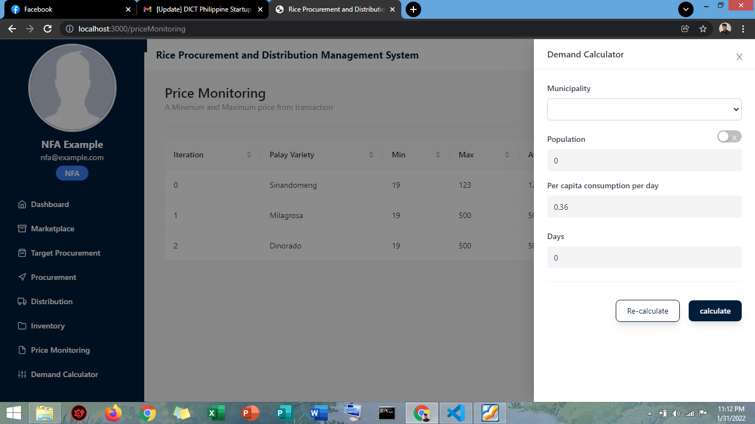

*Figure 33.* Demand Calculator

The purpose of figure 33 is to determine the total number of rice needed to distribute if there are calamities that need relief operation.

Results Interpretation and Analysis

Generally, this research aims to develop a web-based system that can help Filipino farmers in selling their palay produce in the market at a reasonable price and improve the current processes of the NFA in procurement, distribution, and inventory management. This study also gives information on the prices of rice in the market for monitoring.

In this study, the Rapid Application Development Model is used to develop the system and achieve the set objectives. A survey and interview were conducted with the users from farmers, traders, and the NFA personnel to evaluate the system and get insights on recommendations for the further improvement of the system. The researchers used the ISO/IEC 25010 for the survey questionnaire to evaluate the functional suitability, performance efficiency, compatibility, usability, reliability, security, maintainability, and portability of the system. The set of questions in the interview focuses on the problems that the respective users are experiencing. For the farmers, they were asked if the system can help them sell their palay produce more easier and at a reasonable price. Then, the traders were asked if the system helps them buy palay from farmers conveniently. And lastly, the NFA if the system has achieved the desired functionality to support their procurement, inventory management, and distribution processes. Based on their feedback, the system was helpful in tracking the inventory of rice stock of the NFA and made it easier for them to manage and obtain significant data with more dimensionality than what they currently have.

System Evaluation Results

The proposed system was presented to the panel composed of five jurors to determine the quality of the proposed system. The researchers utilized ISO/IEC 25010 to assess the degree to which the system satisfies the presented requirements of the users and provides function to the research problem.

The criteria for evaluation consists of eight sections which involve the following: Functional Suitability, Performance Efficiency, Compatibility, Usability, Reliability, Security, Maintainability and Portability. Using a six-point scale, the form comprises thirty-one statements to measure the quality of the system. Evaluators rated each criterion accordingly and the results are compiled into area means.

Jurors rated each criterion accordingly and the results are compiled into area means. The jurors also provided their recommendations for the improvement of the system.

Users’ Evaluation

The evaluation showed that in the Functional Stability, the jurors rated functional completeness, functional correctness, and functional appropriateness “excellent” with an area mean of 5.2. Performance Efficiency, the jurors rated time behavior, resource utilization, and capacity, “excellent”, with an area mean of 5.26. Compatibility, the jurors rated co-existence, and interoperability “very good”, with an area mean of 4.9. Usability, the jurors rated appropriateness, recognizability, learnability, operability, user error protection, user interface aesthetics, and accessibility “excellent” with an area mean of 5.53. Reliability, the jurors rated maturity, availability, fault tolerance, and recoverability “excellent” with an area mean of 5.25. Security, the jurors rated confidentiality, integrity, nonrepudiation, accountability, and authenticity “very good” with an area mean of 5.08. Maintainability, the jurors rate modularity, reusability, analyzability, modifiability, and testability “excellent” with an area mean of 5.4. Lastly, for portability, the jurors rated adaptability, installability, and replaceability “excellent” with an area mean of 5.6.

**Table 1**

*Evaluation Results for the Proposed System*

Criteria Area Mean

Functional Stability 5.2

Performance Efficiency 5.26

Compatibility 4.9

Reliability 5.53

Security 5.08

Maintainability 5.4

Portability 5.6

Scale. 6.00-5.20 = Excellent; 5.19-4.30 = Very Good; 4.29-3.50 = Good; 3.49-2.70 = Fair; 2.69-1.80 = Poor; 1.79-1.00 = Very Poor.

CHAPTER 5 SUMMARY, CONCLUSIONS AND RECOMMENDATIONS

Summary of the Proposed Study Design and Implementation

The main objective of this study is to develop a web-based system that has a marketplace platform that connects farmers, traders, and the NFA rice market activities. A distribution scheduling, and inventory management system can lessen the workloads of the employees specifically in NFA to gather data and generate information.

This study aims to help the National Food Authority office to input and record data in rice procurement and distribution to easily generate information to visualize and project the data. Furthermore, it enables users to manage their inventory and schedule the allocation of rice to be distributed.

With the rapid advancement of technology, the researchers developed a system that can be used as a primary source of the information exchange tool by integrating rice procurement and prices information from the government agencies to the farmers.

Summary of Findings

The National Food Authority's main function is to ensure food security and to stabilize the supply and price of rice, the primary grain in the country. The NFA shall procure palay locally and maintain the optimal level of buffer stock at all times and dispose of the buffer stock during emergencies and calamities. Based on the data that the researchers have gathered, they found out that the NFA does not have a system that can sufficiently, and reliably give information on rice procurement and distribution of rice and farmers do not have the bargaining power to sell their palay without losing a capital.

The researchers developed a system named “Rice Procurement and Distribution Management System” to provide information about rice procurement, distribution, and rice market activities to the farmer, traders, and NFA. With the use of the system, farmers, traders and NFA would be able to monitor, improve, provide information, and visualize procurement and distribution data. Using the Distribution Scheduling Model NFA user can easily allocate and distribute rice produce and Inventory Model to easily track the Stocks level in the warehouses. The system requires internet connection and computer devices and accessed HTTP and runs in a web browser.

Therefore, using the RAD Model, the researchers have successfully developed the system. In the system analysis and design, from the problems of the users, the researchers were able to identify the functions, features and requirements of the system and design it accordingly. Then, the prototype of the system was developed according to the set objectives. It was then tested and went through numerous iterations, modifications, and quality checks to ensure that the processes and desired results reflect on the user interface without problems to appear. Lastly, the system was deployed through web hosting and implored farmers, traders, and NFA personnels to evaluate the system.

Conclusions

The researchers were able to achieve the objectives set for the study after the evaluation and certain observations were done. The following conclusions were drawn from the results of this study.

The system has successfully interconnected the rice farmers, palay traders, and the NFA through the marketplace and integrated their roles, and corresponding processes that solve some of the problems they have experienced. A web-based system that provides a marketplace platform that conveniently and instantaneously connects farmers, traders, and the NFA for selling and buying rice produce. The system was able to track the supply of palay from different barangays in Iloilo with the complete data from the procurement process. It can manage the in and out of stocks and helps them maintain the stock level of rice in the warehouse. Also, the system can monitor the age of the palay and update the NFA to see if the palay is ready to be milled or if the rice was ready for distribution. It has a demand calculator that can be used to calculate the rice needed to be distributed to municipalities during relief operations. The NFA can have a better method of monitoring the farmgate prices of palay to ensure that the amount is within the price range. The dashboard provides insights to help the NFA plan and formulate strategies in the procurement of palay. The system is evaluated through the ISO 25010 to determine the quality of the system in terms of its usability, more particularly in effectiveness, efficiency, and satisfaction in giving reliable information that could greatly help on palay procurement and distribution of rice.

Recommendations

Considering the results previously presented and the conclusion drawn and discussed the following are the recommendations for the improvement of the system. future developer should be able to determine that:

1. The system will be implemented in the National Food Authority office and will be able to assist the admin with their everyday transactions.
2. The NFA Operations Personnel can export the data from procurement and distribution tables into an excel file.
3. The system can be developed into a mobile application version for easy user access.

References

Abrogena, N. O., Galut, C., Aguinaldo, A.C., Duldulao, V.A., (1970) *Palay/rice trading in the Philippines: an evaluation for the rice R & D [research and development]* https://agris.fao.org/agris search/search.do?recordID=PH2001100596

Alam, S., Haque, S., Islam, S., Jannat, A., Islam, M. (2017). *Feasibility of rice procurement programme for poor farmers in Bangladesh*. <https://www.researchgate.net/publication/319017703_Feasibility_of_rice_procurement_programme_for_poor_farmers_in_Bangladesh>

Alfazah, D. A., Ridwan, A.D., Yulianti, F. and Kusuma, P. G. (2019) *Designing Procurement Process Monitoring Dashboard for Supporting Food Security Supply Chain Risk Management System in Indonesian Bureau of Logistics* https://ieeexplore.ieee.org/abstract/document/8985503

Briones, R. (2019) *Competition in the Rice Industry: An Issues Paper* <https://www.phcc.gov.ph/wp-content/uploads/2019/03/Issues-Paper-Rice-030819-cover-1.pdf>

CareerExplorer. (2019, November 14). *What does a farmer do?* https://www.careerexplorer.com/careers/farmer/

FAOSTAT. 2020. FAO. http://www.fao.org/faostat/en/#data. Accessed on June 25, 2020.

Harahap, Parlindungan & Virgana, R. & Hapsari, Wiwik & Anwar, Tezza. (2019). *Analysis of Distribution Information System of Rice Supply Chain Management at PT.* Jatisari Sri Rejeki. International Journal of Financial Research. <https://www.researchgate.net/publication/333724217_Analysis_of_Distribution_Information_System_of_Rice_Supply_Chain_Management_at_PT_Jatisari_Sri_Rejeki>

*Inside Procurement*. (2020, December 27). Investopedia. https://www.investopedia.com/terms/p/procurement.asp

*Inventory Management Defined Plus Methods and Techniques*. (2022, July 25). Investopedia. https://www.investopedia.com/terms/i/inventory-management.asp

Kenton, W. (2023, January 5). Exchanges: Explanation, types and examples. Investopedia. Retrieved January 11, 2023, from https://www.investopedia.com/terms/e/exchange.asp

Manila Bulletin. (2007). NGOs Opposed Entry of GM rice into the country Manila Bulletin 410: 27 page B-12.

Mataia, A., Beltran, J., et al. (2020). *Rice Value Chain Analysis in the Philippines: Value Addition, Constraints, and Upgrading Strategies.* https://www.researchgate.net/publication/346974332_Rice_Value_Chain_Analysis_in_the_Philippines_Value_Addition_Constraints_and_Upgrading_Strategies

Megida, D. (2021, April 29). *What is JavaScript? A Definition of the JS Programming Language*. freeCodeCamp.Org. https://www.freecodecamp.org/news/what-is-javascript-defination-of-js/

[Mohammad](https://ageconsearch.umn.edu/search?f1=author&as=1&sf=title&so=a&rm=&m1=e&p1=Alam%2C%20Mohammad&ln=en), A., [Shaheen](https://ageconsearch.umn.edu/search?f1=author&as=1&sf=title&so=a&rm=&m1=e&p1=Akter%2C%20Shaheen&ln=en), A., [Ismat](https://ageconsearch.umn.edu/search?f1=author&as=1&sf=title&so=a&rm=&m1=e&p1=Begum%2C%20Ismat&ln=en), B. (2015) *Effectiveness of Rice Procurement Program and the Determinants of the Farm Level Stocks of Rice in Bangladesh* https://ageconsearch.umn.edu/record/210942*/*

Morris, S. (2022, June 2). Tech 101: What is React JS? Skillcrush. https://skillcrush.com/blog/what-is-react-js/

N. (2019, February 18). *Price manipulation seen as ‘pitfall’ under new rice regime*. BusinessWorld Online. https://www.bworldonline.com/economy/2019/02/18/214990/price-manipulation-seen-as-pitfall-under-new-rice-regime/

Nicavera, E. (2020) *Palay production in Western Visayas grows by 12.15% in H1* <https://www.pna.gov.ph/articles/1113535>

Palay. (n.d.). The Merriam-Webster.Com Dictionary. https://www.merriam-webster.com/dictionary/palay

Philippines - Global yield gap atlas. (n.d.). Yieldgap.Org. https://www.yieldgap.org/philippines

Purugganan, J. (2019, November 26). *Farmers Demand Government to repeal Rice Liberalization law*. Focus on the Global South. Retrieved May 18, 2021, from https://focusweb.org/farmers-demand-government-to-repeal-rice-liberalization-law/

Republic act no. 11203. (2018). Retrieved May 18, 2021, from https://lawphil.net/statutes/repacts/ra2019/ra_11203_2019.html

*Rice | Description, History, Cultivation, & Uses*. (n.d.). Encyclopedia Britannica. https://www.britannica.com/plant/rice

Rosencrance, L. (2019, April 25). *Google Firebase*. SearchMobileComputing.https://www.techtarget.com/searchmobilecomputing/definition/Google-Firebase

Sahirman, S., Ardiansyah, Rifan, M., Melmambessy, E. (2019). *Transportation model and techno economic as useful tools in agroindustry clustering: a case study in district Semangga, Merauke.* https://www.researchgate.net/figure/Transportation-model-to-minimize-total-costs-associated-with-rice-production-and_fig1_332232523

Sharma, V., Giri, S., & Rai, S. (2013). *Supply Chain Management Of Rice In India: A Rice Processing Company's Perspective.* International Journal of Managing Value and Supply Chains. https://www.researchgate.net/publication/274174132_Supply_Chain_Management_Of_Rice_In_India_A_Rice_Processing_Company's_Perspective/citation/download

*Study.com | Take Online Courses. Earn College Credit. Research Schools, Degrees & Careers*. (n.d.). Retrieved October 15, 2022, from https://study.com/academy/lesson/schedule-modeling-definition-use-in-project-management.html

*Trader - Definition, Meaning & Synonyms*. (n.d.). Vocabulary.Com. https://www.vocabulary.com/dictionary/trader

The Economic Times. (n.d.). *What is Distribution? Definition of Distribution, Distribution Meaning*. https://economictimes.indiatimes.com/definition/distribution

Vidal, F. (2019, March 20). *What Is A Marketplace? Our understanding of multi-seller businesses*. Www.Shopery.Com.[https://www.shopery](https://www.shopery/). com/insights/what-is-a-marketplace

Wikipedia contributors. (2022, March 13). *National Food Authority (Philippines)*. Wikipedia. https://en.wikipedia.org/wiki/National_Food_Authority_(Philippines)#:%7E:text=The%20Philippines’%20National%20Food%20Authority,of%20rice%2C%20the%20Philippines’%20staple